RAJALAKSHMI ENGINEERING COLLEGE



**RAJALAKSHMI NAGAR, THANDALAM – 602 105**

**Laboratory Record Note Book**

**CS19611**

**Mobile Application Development Laboratory**

Name : YOGESH CV . . . . . . . . . . . . . . . . . . . . . . . . . . . . . . . . . . . . . . . . . . . . . . . . . Year / Branch / Section : III / CSE / D . . . . . . . . . . . . . . . . . . . . . . . . . . . . . . . . . .

Register No. : 2116220701327. . . . . . . . . . . . . . . . . . . . . . . . . . . . . . . . . . . .

Semester : VI . . . . . . . . . . . . . . . . . . . . . . . . . . . . . . . . . . . . . . . . . . . . . . . . . . . . .

Academic Year : 2024-25 . . . . . . . . . . . . . . . . . . . . . . . . . . . . . . . . . . . . . . . . . . . . . .

**2**

**Dept. of Computer Science and Engineering** | **Rajalakshmi Engineering College**

RAJALAKSHMI ENGINEERING COLLEGE



**RAJALAKSHMI NAGAR, THANDALAM – 602 105**

**BONAFIDE CERTIFICATE**

Name : YOGESH CV . . . . . . . . . . . . . . . . . . . . . . . . . . . . . . . . . . . . . . . . . . . . . . . . . . . .

Academic Year : 2024-25 . . . . . . . . . . . . . Semester : VI. . . . . . . Branch : CSE . . . . . .

**Register No.**

**2116220701327**

*Certified that this is the bonafide record of work done by the above student in the*

*. Laboratory during the year*

*2024 - 2025*

**Signature of Faculty in-charge**

Submitted for the Practical Examination held on . . . . . . . . . . . . . . . . . . . . . . . . . . . . .

**Internal Examiner External Examiner**

**Dept. of Computer Science and Engineering** | **Rajalakshmi Engineering College**

**3**

**4**

**Dept. of Computer Science and Engineering** | **Rajalakshmi Engineering College**

# INDEX



Reg. No. : 220701327 Name : YOGESH CV

Year : III Branch : CSE Sec : D

|  |  |  |  |  |
| --- | --- | --- | --- | --- |
| **S.**  **No.** | **Date** | **Title** | **Page No.** | **Teacher’s**  **Signature / Remarks** |
| 1 |  | GUI Components | 7 |  |
| 2 |  | Simple Calculator | 12 |  |
| 3 |  | Graphical Primitives | 21 |  |
| 4 |  | Android Fragments | 27 |  |
| 5 |  | SQLite | 36 |  |
| 6 |  | Form Validation | 45 |  |
| 7 |  | SD Card | 53 |  |
| 8 |  | Alert Dialog Box | 58 |  |
| 9 |  | Alarm | 64 |  |
| 10 |  | Telephony Services | 70 |  |
| 11 |  | Send SMS | 76 |  |
| 12 |  | Send Email | 81 |  |
| 13 |  | Text to Speech | 86 |  |
| 14 |  | Speech to Text | 91 |  |
| 15 |  | Image Capture | 96 |  |

**Dept. of Computer Science and Engineering** | **Rajalakshmi Engineering College**

**5**

**6**

**Dept. of Computer Science and Engineering** | **Rajalakshmi Engineering College**

**Ex. No. : 01 Date :**



**Register No. : Name :**

**GUI Components**

**Aim**

Develop an application to change the font and color of the text and display toast message when the user presses the button.

# Procedure

**Dept. of Computer Science and Engineering** | **Rajalakshmi Engineering College**

**7**

# AndroidManifest.xml

**8**

*<?*xml version="1.0" encoding="utf-8"*?>*

<manifest xmlns:android="<http://schemas.android.com/apk/res/android>" xmlns:tools="<http://schemas.android.com/tools>">

<application

android:allowBackup="true" android:dataExtractionRules="@xml/data_extraction_rules" android:fullBackupContent="@xml/backup_rules" android:icon="@mipmap/ic_launcher" android:label="@string/app_name" android:supportsRtl="true" android:theme="@style/Theme.GUIComponents" tools:targetApi="31">

<activity

android:name=".MainActivity" android:exported="true">

<intent-filter>

<action android:name="android.intent.action.MAIN" />

<category android:name="android.intent.category.LAUNCHER" />

</intent-filter>

</**activity**>

</**application**>

</**manifest**>

**Dept. of Computer Science and Engineering** | **Rajalakshmi Engineering College**

# activity_main.xml



*<?*xml version="1.0" encoding="utf-8"*?>*

<LinearLayout xmlns:android="<http://schemas.android.com/apk/res/android>" xmlns:app="<http://schemas.android.com/apk/res-auto>" xmlns:tools="<http://schemas.android.com/tools>" android:id="@+id/linearLayout"

android:layout_width="match_parent" android:layout_height="match_parent" android:orientation="vertical" tools:context=".MainActivity" >

<TextView

android:id="@+id/tvText" android:layout_width="match_parent" android:layout_height="wrap_content" android:text="Rajalakshmi Engineering College" android:textAlignment="center" android:textSize="16sp" />

<Button

android:id="@+id/btFontSize" android:layout_width="match_parent" android:layout_height="wrap_content" android:inputType="textCapSentences" android:text="Change Font Size" android:textSize="16sp" />

<Button

android:id="@+id/btFontColor" android:layout_width="match_parent" android:layout_height="wrap_content" android:inputType="textCapSentences" android:text="Change Font Color" android:textSize="16sp" />

<Button

android:id="@+id/btBackgroundColor" android:layout_width="match_parent" android:layout_height="wrap_content" android:inputType="textCapSentences" android:text="Change Background Color" android:textSize="16sp" />

</LinearLayout>

**Dept. of Computer Science and Engineering** | **Rajalakshmi Engineering College**

**9**

# MainActivity.kt

**10**

**package** org.rajalakshmi.guicomponents

**import** android.graphics.Color

**import** androidx.appcompat.app.AppCompatActivity

**import** android.os.Bundle

**import** android.widget.Button **import** android.widget.LinearLayout **import** android.widget.TextView

**class** MainActivity : AppCompatActivity() {

**override fun** onCreate(savedInstanceState: Bundle?) { **super**.onCreate(savedInstanceState) setContentView(R.layout.*activity_main*)

**val** tvText : TextView = findViewById(R.id.*tvText*)

**val** btFontSize : Button = findViewById(R.id.*btFontSize*)

**val** btFontColor : Button = findViewById(R.id.*btFontColor*)

**val** btBackgroundColor : Button = findViewById(R.id.*btBackgroundColor*)

**val** linearLayout : LinearLayout = findViewById(R.id.*linearLayout*)

**var** fontSize : Float = 5f

**var** fontColor : Int = 0

**var** backgroundColor : Int = 0

btFontSize.setOnClickListener **{** tvText.setTextSize(fontSize) fontSize = (fontSize + 5) % 50

**}**

btFontColor.setOnClickListener **{ when**(fontColor % 3) {

1. -> tvText.setTextColor(Color.*RED*)
2. -> tvText.setTextColor(Color.*GREEN*)
3. -> tvText.setTextColor(Color.*BLUE*)

}

fontColor++

**}**

btBackgroundColor.setOnClickListener **{ when**(backgroundColor % 3) {

1. -> linearLayout.setBackgroundColor(Color.*RED*)
2. -> linearLayout.setBackgroundColor(Color.*GREEN*)
3. -> linearLayout.setBackgroundColor(Color.*BLUE*)

}

backgroundColor++

**}**

}

}

**Dept. of Computer Science and Engineering** | **Rajalakshmi Engineering College**

Output

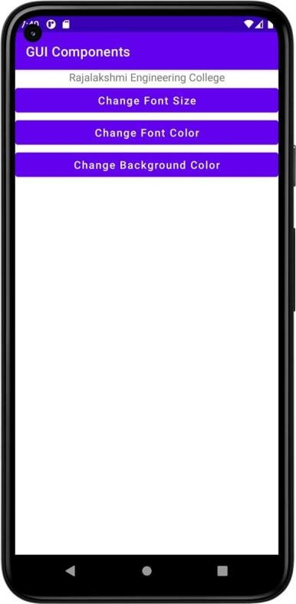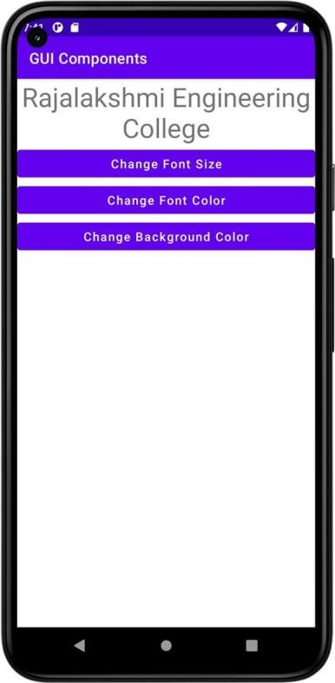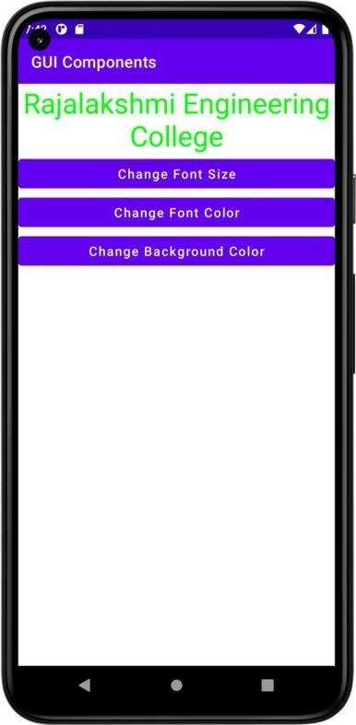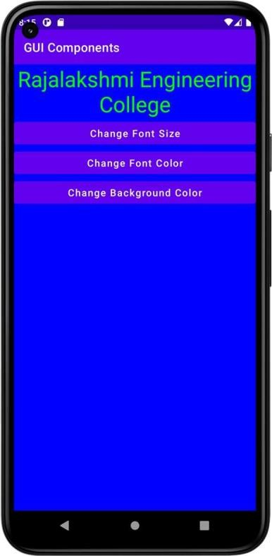

# Result

**Dept. of Computer Science and Engineering** | **Rajalakshmi Engineering College**

**11**

**Ex. No. : 02 Date :**

**12**

**Register No. : Name :**

**Simple Calculator**

**Aim**

Develop a simple calculator to perform arithmetic and mathematical functions using Math class.

# Procedure

**Dept. of Computer Science and Engineering** | **Rajalakshmi Engineering College**

# AndroidManifest.xml



*<?*xml version="1.0" encoding="utf-8"*?>*

<manifest xmlns:android="<http://schemas.android.com/apk/res/android>" xmlns:tools="<http://schemas.android.com/tools>">

<application

android:allowBackup="true" android:dataExtractionRules="@xml/data_extraction_rules" android:fullBackupContent="@xml/backup_rules" android:icon="@mipmap/ic_launcher" android:label="@string/app_name" android:supportsRtl="true" android:theme="@style/Theme.SimpleCalculator" tools:targetApi="31">

<activity

android:name=".MainActivity" android:exported="true">

<intent-filter>

<action android:name="android.intent.action.MAIN" />

<category android:name="android.intent.category.LAUNCHER" />

</intent-filter>

</**activity**>

</**application**>

</**manifest**>

**Dept. of Computer Science and Engineering** | **Rajalakshmi Engineering College**

**13**

# activity_main.xml

**14**

*<?*xml version="1.0" encoding="utf-8"*?>*

<LinearLayout xmlns:android="<http://schemas.android.com/apk/res/android>" xmlns:app="<http://schemas.android.com/apk/res-auto>" xmlns:tools="<http://schemas.android.com/tools>" android:layout_width="match_parent" android:layout_height="match_parent"

android:orientation="vertical" tools:context=".MainActivity">

<TextView

android:id="@+id/tvExpression" android:layout_width="match_parent" android:layout_height="wrap_content" android:textSize="60sp" />

<TextView

android:id="@+id/tvResult" android:layout_width="match_parent" android:layout_height="wrap_content" android:textSize="60sp" />

<LinearLayout

android:layout_width="match_parent" android:layout_height="50dp" android:orientation="horizontal">

<Button

android:id="@+id/btSeven" android:layout_width="wrap_content" android:layout_height="wrap_content" android:layout_weight="1" android:text="7" />

<Button

android:id="@+id/btEight" android:layout_width="wrap_content" android:layout_height="wrap_content" android:layout_weight="1" android:text="8" />

<Button

android:id="@+id/btNine" android:layout_width="wrap_content" android:layout_height="wrap_content" android:layout_weight="1" android:text="9" />

<Button

android:id="@+id/btDivision" android:layout_width="wrap_content" android:layout_height="wrap_content" android:layout_weight="1" android:text="/" />

</LinearLayout>

<LinearLayout

android:layout_width="match_parent" android:layout_height="50dp" android:orientation="horizontal">

**Dept. of Computer Science and Engineering** | **Rajalakshmi Engineering College**

<Button



android:id="@+id/btFour" android:layout_width="wrap_content" android:layout_height="wrap_content" android:layout_weight="1" android:text="4" />

<Button

android:id="@+id/btFive" android:layout_width="wrap_content" android:layout_height="wrap_content" android:layout_weight="1" android:text="5" />

<Button

android:id="@+id/btSix" android:layout_width="wrap_content" android:layout_height="wrap_content" android:layout_weight="1" android:text="6" />

<Button

android:id="@+id/btMultiplication" android:layout_width="wrap_content" android:layout_height="wrap_content" android:layout_weight="1" android:text="X" />

</LinearLayout>

<LinearLayout

android:layout_width="match_parent" android:layout_height="50dp" android:orientation="horizontal">

<Button

android:id="@+id/btOne" android:layout_width="wrap_content" android:layout_height="wrap_content" android:layout_weight="1" android:text="1" />

<Button

android:id="@+id/btTwo" android:layout_width="wrap_content" android:layout_height="wrap_content" android:layout_weight="1" android:text="2" />

<Button

android:id="@+id/btThree" android:layout_width="wrap_content" android:layout_height="wrap_content" android:layout_weight="1" android:text="3" />

<Button

android:id="@+id/btSubtraction" android:layout_width="wrap_content" android:layout_height="wrap_content" android:layout_weight="1" android:text="-" />

**Dept. of Computer Science and Engineering** | **Rajalakshmi Engineering College**

**15**

</LinearLayout>

**16**

<LinearLayout

android:layout_width="match_parent" android:layout_height="50dp" android:orientation="horizontal">

<Button

android:id="@+id/btDecimal" android:layout_width="wrap_content" android:layout_height="wrap_content" android:layout_weight="1" android:text="." />

<Button

android:id="@+id/btZero" android:layout_width="wrap_content" android:layout_height="wrap_content" android:layout_weight="1" android:text="0" />

<Button

android:id="@+id/btEqual" android:layout_width="wrap_content" android:layout_height="wrap_content" android:layout_weight="1" android:text="=" />

<Button

android:id="@+id/btAddition" android:layout_width="wrap_content" android:layout_height="wrap_content" android:layout_weight="1" android:text="+" />

</LinearLayout>

<Button

android:id="@+id/btClear" android:layout_width="match_parent" android:layout_height="wrap_content" android:text="Clear" android:textAllCaps="false" />

</LinearLayout>

**Dept. of Computer Science and Engineering** | **Rajalakshmi Engineering College**

# MainActivity.xml



**package** org.rajalakshmi.simplecalculator

**import** androidx.appcompat.app.AppCompatActivity

**import** android.os.Bundle **import** android.widget.Button **import** android.widget.TextView

**class** MainActivity : AppCompatActivity() {

**var input1** :Double = 0.0

**var input2** :Double = 0.0

**var addition** : Boolean = **false var subtraction** : Boolean = **false**

**var multiplication** : Boolean = **false var division** : Boolean = **false**

**var decimal** : Boolean = **false**

**override fun** onCreate(savedInstanceState: Bundle?) { **super**.onCreate(savedInstanceState) setContentView(R.layout.*activity_main*)

**val** tvExpression : TextView = findViewById(R.id.*tvExpression*)

**val** tvResult : TextView = findViewById(R.id.*tvResult*)

**val** btZero : Button = findViewById(R.id.*btZero*) **val** btOne : Button = findViewById(R.id.*btOne*) **val** btTwo : Button = findViewById(R.id.*btTwo*) **val** btThree : Button = findViewById(R.id.*btThree*) **val** btFour : Button = findViewById(R.id.*btFour*) **val** btFive : Button = findViewById(R.id.*btFive*) **val** btSix : Button = findViewById(R.id.*btSix*)

**val** btSeven : Button = findViewById(R.id.*btSeven*) **val** btEight : Button = findViewById(R.id.*btEight*) **val** btNine : Button = findViewById(R.id.*btNine*)

**val** btAddition : Button = findViewById(R.id.*btAddition*)

**val** btSubtraction : Button = findViewById(R.id.*btSubtraction*)

**val** btMultiplication : Button = findViewById(R.id.*btMultiplication*)

**val** btDivision : Button = findViewById(R.id.*btDivision*) **val** btDecimal : Button = findViewById(R.id.*btDecimal*) **val** btEqual : Button = findViewById(R.id.*btEqual*)

**val** btClear : Button = findViewById(R.id.*btClear*)

btZero.setOnClickListener **{**

tvExpression.setText(**"${**tvExpression.*text***}0"**)

**}**

btOne.setOnClickListener **{**

tvExpression.setText(**"${**tvExpression.*text***}1"**)

**}**

btTwo.setOnClickListener **{**

tvExpression.setText(**"${**tvExpression.*text***}2"**)

**}**

btThree.setOnClickListener **{**

tvExpression.setText(**"${**tvExpression.*text***}3"**)

**}**

btFour.setOnClickListener **{**

tvExpression.setText(**"${**tvExpression.*text***}4"**)

**}**

btFive.setOnClickListener **{**

tvExpression.setText(**"${**tvExpression.*text***}5"**)

**}**

btSix.setOnClickListener **{**

tvExpression.setText(**"${**tvExpression.*text***}6"**)

**Dept. of Computer Science and Engineering** | **Rajalakshmi Engineering College**

**17**

**}**

**18**

btSeven.setOnClickListener **{**

tvExpression.setText(**"${**tvExpression.*text***}7"**)

**}**

btEight.setOnClickListener **{**

tvExpression.setText(**"${**tvExpression.*text***}8"**)

**}**

btNine.setOnClickListener **{**

tvExpression.setText(**"${**tvExpression.*text***}9"**)

**}**

btDecimal.setOnClickListener **{ if**(!**decimal**) {

tvExpression.setText(**"${**tvExpression.*text***}."**)

decimal = true

}

**}**

btAddition.setOnClickListener **{**

**if** (tvExpression.getText().**length** != 0) { **input1** = **"${**tvExpression.*text***}"**.*toDouble*() **addition** = **true**

decimal = false

tvExpression.setText(**null**)

}

**}**

btSubtraction.setOnClickListener **{**

**if** (tvExpression.getText().**length** != 0) { **input1** = **"${**tvExpression.*text***}"**.*toDouble*() **subtraction** = **true**

decimal = false

tvExpression.setText(**null**)

}

**}**

btMultiplication.setOnClickListener **{**

**if** (tvExpression.getText().**length** != 0) { **input1** = **"${**tvExpression.*text***}"**.*toDouble*() **multiplication** = **true**

decimal = false

tvExpression.setText(**null**)

}

**}**

btDivision.setOnClickListener **{**

**if** (tvExpression.getText().**length** != 0) { **input1** = **"${**tvExpression.*text***}"**.*toDouble*() **division** = **true**

decimal = false

tvExpression.setText(**null**)

}

**}**

btEqual.setOnClickListener() **{**

**input2** = **"${**tvExpression.*text***}"**.*toDouble*() **if** (**addition**) {

tvExpression.setText(**"${input1} + ${input2}"**) **val** raddition : Double = **input1** + **input2** tvResult.setText(**"${**raddition**}"**)

addition = false

}

**if** (**subtraction**) { tvExpression.setText(**"${input1} - ${input2}"**) **val** rsubtraction : Double = **input1** - **input2** tvResult.setText(**"${**rsubtraction**}"**) **subtraction** = **false**

}

**Dept. of Computer Science and Engineering** | **Rajalakshmi Engineering College**

**if** (**multiplication**) { tvExpression.setText(**"${input1} * ${input2}"**) **val** rmultiplication : Double = **input1** * **input2** tvResult.setText(**"${**rmultiplication**}"**) **multiplication** = **false**



}

**if** (**division**) {

tvExpression.setText(**"${input1} / ${input2}"**) **val** rdivision : Double = **input1** / **input2** tvResult.setText(**"${**rdivision**}"**)

division = false

}

**}**

btClear.setOnClickListener **{** tvExpression.setText(**""**) tvResult.setText(**""**) **input1** = 0.0

**input2** = 0.0

decimal = false

**}**

}

}

**Dept. of Computer Science and Engineering** | **Rajalakshmi Engineering College**

**19**

# Output

**20**

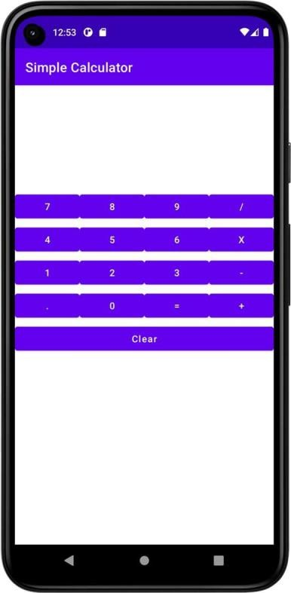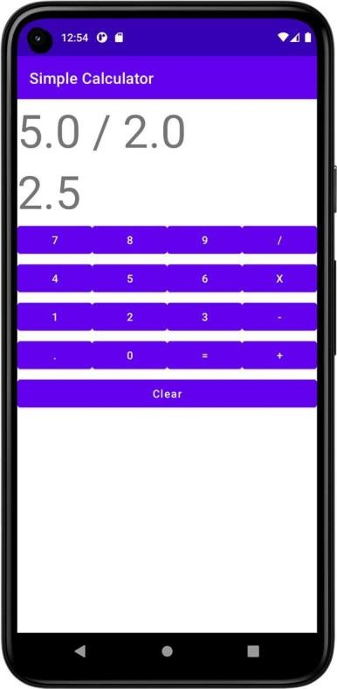

**Dept. of Computer Science and Engineering** | **Rajalakshmi Engineering College**

**Ex. No. : 03 Date :**



**Register No. : Name :**

**Graphical Primitives**

**Aim**

Develop an android application to draw the circle, ellipse, rectangle and some text using Android Graphical primitives.

# Procedure

**Dept. of Computer Science and Engineering** | **Rajalakshmi Engineering College**

**21**

# AndroidManifest.xml

**22**

*<?*xml version="1.0" encoding="utf-8"*?>*

<manifest xmlns:android="<http://schemas.android.com/apk/res/android>" xmlns:tools="<http://schemas.android.com/tools>">

<application

android:allowBackup="true" android:dataExtractionRules="@xml/data_extraction_rules" android:fullBackupContent="@xml/backup_rules" android:icon="@mipmap/ic_launcher" android:label="@string/app_name" android:supportsRtl="true" android:theme="@style/Theme.GraphicalPrimitives" tools:targetApi="31">

<activity

android:name=".MainActivity" android:exported="true">

<intent-filter>

<action android:name="android.intent.action.MAIN" />

<category android:name="android.intent.category.LAUNCHER" />

</intent-filter>

</**activity**>

</**application**>

</**manifest**>

**Dept. of Computer Science and Engineering** | **Rajalakshmi Engineering College**

# activity_main.xml



*<?*xml version="1.0" encoding="utf-8"*?>*

<androidx.constraintlayout.widget.ConstraintLayout xmlns:android="<http://schemas.android.com/apk/res/android>"

xmlns:app="<http://schemas.android.com/apk/res-auto>" xmlns:tools="<http://schemas.android.com/tools>" android:layout_width="match_parent" android:layout_height="match_parent" tools:context=".MainActivity">

<org.rajalakshmi.graphicalprimitives.SampleCanvas android:layout_width="match_parent" android:layout_height="match_parent">

</org.rajalakshmi.graphicalprimitives.SampleCanvas>

</androidx.constraintlayout.widget.ConstraintLayout>

**Dept. of Computer Science and Engineering** | **Rajalakshmi Engineering College**

**23**

# MainActivity.kt

**24**

**package** org.rajalakshmi.graphicalprimitives

**import** androidx.appcompat.app.AppCompatActivity

**import** android.os.Bundle

**class** MainActivity : AppCompatActivity() {

**override fun** onCreate(savedInstanceState: Bundle?) { **super**.onCreate(savedInstanceState) setContentView(R.layout.*activity_main*)

}

}

**Dept. of Computer Science and Engineering** | **Rajalakshmi Engineering College**

# SampleCanvas.kt



**package** org.rajalakshmi.graphicalprimitives

**import** android.content.Context **import** android.graphics.Canvas **import** android.graphics.Color **import** android.graphics.Paint **import** android.util.AttributeSet **import** android.view.View

**class** SampleCanvas @JvmOverloads **constructor**(

context: Context, attrs: AttributeSet? = **null**, defStyleAttr: Int = 0

) : View(context, attrs, defStyleAttr) {

**override fun** onDraw(canvas: Canvas?) {

**super**.onDraw(canvas)

**val** paint : Paint = Paint() paint.setColor(Color.*YELLOW*) canvas?.drawPaint(paint) paint.setTextSize(50f); paint.setColor(Color.*RED*); canvas?.drawText(**"Circle"**, 120f, 150f, paint); canvas?.drawCircle(200f, 350f, 150f, paint); paint.setColor(Color.*GREEN*);

canvas?.drawText(**"Rectangle"**, 420f, 150f, paint); canvas?.drawRect(400f, 200f, 650f, 700f, paint); paint.setColor(Color.*BLUE*); canvas?.drawText(**"Square"**, 120f, 800f, paint); canvas?.drawRect(50f, 850f, 350f, 1150f, paint); paint.setColor(Color.*BLACK*); canvas?.drawText(**"Line"**, 480f, 800f, paint); canvas?.drawLine(520f, 850f, 520f, 1150f, paint);

}

}

**Dept. of Computer Science and Engineering** | **Rajalakshmi Engineering College**

**25**

# Output

**26**

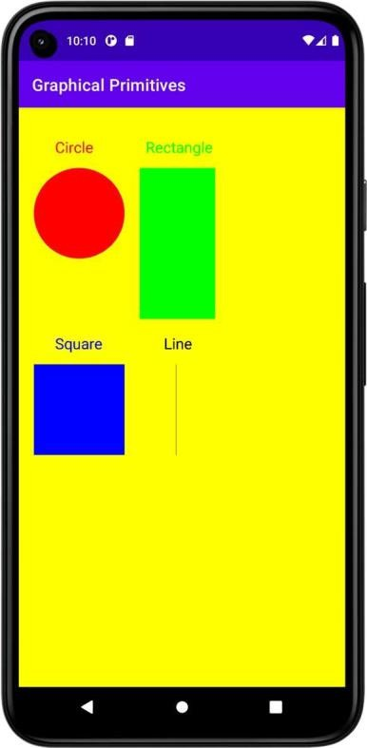

**Result**

**Dept. of Computer Science and Engineering** | **Rajalakshmi Engineering College**

**Ex. No. : 04 Date :**



**Register No. : Name :**

**Android Fragments**

**Aim**

Develop an android application to create two activities named as Student Basic Details (Register No., Name, Department) and Student Mark Details (SSLC, HSC, UG). Write an android code to combine these two activities in single screen using android fragment.

# Procedure

**Dept. of Computer Science and Engineering** | **Rajalakshmi Engineering College**

**27**

# AndroidManifest.xml

**28**

*<?*xml version="1.0" encoding="utf-8"*?>*

<manifest xmlns:android="<http://schemas.android.com/apk/res/android>" xmlns:tools="<http://schemas.android.com/tools>">

<application

android:allowBackup="true" android:dataExtractionRules="@xml/data_extraction_rules" android:fullBackupContent="@xml/backup_rules" android:icon="@mipmap/ic_launcher" android:label="@string/app_name" android:supportsRtl="true" android:theme="@style/Theme.AndroidFragments" tools:targetApi="31">

<activity

android:name=".MainActivity" android:exported="true">

<intent-filter>

<action android:name="android.intent.action.MAIN" />

<category android:name="android.intent.category.LAUNCHER" />

</intent-filter>

</**activity**>

</**application**>

</**manifest**>

**Dept. of Computer Science and Engineering** | **Rajalakshmi Engineering College**

# activity_main.xml



*<?*xml version="1.0" encoding="utf-8"*?>*

<LinearLayout xmlns:android="<http://schemas.android.com/apk/res/android>" xmlns:app="<http://schemas.android.com/apk/res-auto>" xmlns:tools="<http://schemas.android.com/tools>" android:layout_width="match_parent" android:layout_height="match_parent"

android:orientation="vertical" tools:context=".MainActivity">

<TextView

android:id="@+id/tvTitle" android:layout_width="match_parent" android:layout_height="wrap_content" android:text="Student Details" android:textAlignment="center" android:textSize="24sp" />

<LinearLayout

android:layout_width="match_parent" android:layout_height="match_parent" android:orientation="vertical">

<fragment

android:id="@+id/fragmentBasic" android:name="org.rajalakshmi.androidfragments.StudentBasicDetails" android:layout_width="match_parent"

android:layout_height="300dp" />

<fragment

android:id="@+id/fragmentMark" android:name="org.rajalakshmi.androidfragments.StudentMarkDetails" android:layout_width="match_parent"

android:layout_height="300dp" />

</LinearLayout>

</LinearLayout>

**Dept. of Computer Science and Engineering** | **Rajalakshmi Engineering College**

**29**

# fragment_student_basic_details.xml

**30**

*<?*xml version="1.0" encoding="utf-8"*?>*

<FrameLayout xmlns:android="<http://schemas.android.com/apk/res/android>" xmlns:tools="<http://schemas.android.com/tools>" android:layout_width="match_parent" android:layout_height="match_parent" tools:context=".StudentBasicDetails">

<TextView

android:id="@+id/tvBasicDetails" android:layout_width="match_parent" android:layout_height="wrap_content" android:text="Basic Details" android:textAlignment="center" android:textSize="24sp" />

<TextView

android:id="@+id/tvRegisterNumber" android:layout_width="wrap_content" android:layout_height="wrap_content" android:layout_marginTop="50dp" android:text="Register No." />

<EditText

android:id="@+id/etRegisterNumber" android:layout_width="wrap_content" android:layout_height="wrap_content" android:layout_marginLeft="150dp" android:layout_marginTop="50dp" android:ems="10" android:hint="Register Number" android:inputType="textPersonName" />

<TextView

android:id="@+id/tvName" android:layout_width="wrap_content" android:layout_height="wrap_content" android:layout_marginTop="125dp" android:text="Name" />

<EditText

android:id="@+id/etName" android:layout_width="wrap_content" android:layout_height="wrap_content" android:layout_marginLeft="150dp" android:layout_marginTop="125dp" android:ems="10" android:hint="Name"

android:inputType="textPersonName" />

<TextView

android:id="@+id/tvDepartment" android:layout_width="wrap_content" android:layout_height="wrap_content" android:layout_marginTop="200dp" android:text="Department" />

<EditText

android:id="@+id/etDepartment" android:layout_width="wrap_content" android:layout_height="wrap_content" android:layout_marginLeft="150dp" android:layout_marginTop="200dp" android:ems="10" android:hint="Department" android:inputType="textPersonName" />

</**FrameLayout**>

**Dept. of Computer Science and Engineering** | **Rajalakshmi Engineering College**

# fragment_student_mark_details.xml



*<?*xml version="1.0" encoding="utf-8"*?>*

<FrameLayout xmlns:android="<http://schemas.android.com/apk/res/android>" xmlns:tools="<http://schemas.android.com/tools>" android:layout_width="match_parent" android:layout_height="match_parent" tools:context=".StudentMarkDetails">

<TextView

android:id="@+id/tvBasicDetails" android:layout_width="match_parent" android:layout_height="wrap_content" android:text="Mark Details" android:textAlignment="center" android:textSize="24sp" />

<TextView

android:id="@+id/tvSSLC" android:layout_width="wrap_content" android:layout_height="wrap_content" android:layout_marginTop="50dp" android:text="S.S.L.C." />

<EditText

android:id="@+id/etSSLC" android:layout_width="wrap_content" android:layout_height="wrap_content" android:layout_marginLeft="150dp" android:layout_marginTop="50dp" android:ems="10" android:hint="S.S.L.C. Mark" android:inputType="textPersonName" />

<TextView

android:id="@+id/tvHSc" android:layout_width="wrap_content" android:layout_height="wrap_content" android:layout_marginTop="125dp" android:text="H.Sc." />

<EditText

android:id="@+id/etHSC" android:layout_width="wrap_content" android:layout_height="wrap_content" android:layout_marginLeft="150dp" android:layout_marginTop="125dp" android:ems="10" android:hint="H.Sc. Mark"

android:inputType="textPersonName" />

<TextView

android:id="@+id/tvUG" android:layout_width="wrap_content" android:layout_height="wrap_content" android:layout_marginTop="200dp" android:text="U.G." />

<EditText

android:id="@+id/etUG" android:layout_width="wrap_content" android:layout_height="wrap_content" android:layout_marginLeft="150dp" android:layout_marginTop="200dp" android:ems="10"

android:hint="U.G. C.G.P.A." android:inputType="textPersonName" />

</**FrameLayout**>

**Dept. of Computer Science and Engineering** | **Rajalakshmi Engineering College**

**31**

# MainActivity.kt

**32**

**package** org.rajalakshmi.androidfragments

**import** androidx.appcompat.app.AppCompatActivity

**import** android.os.Bundle

**class** MainActivity : AppCompatActivity() {

**override fun** onCreate(savedInstanceState: Bundle?) { **super**.onCreate(savedInstanceState) setContentView(R.layout.*activity_main*)

}

}

**Dept. of Computer Science and Engineering** | **Rajalakshmi Engineering College**

# StudentBasicDetails.kt



**package** org.rajalakshmi.androidfragments

**import** android.os.Bundle

**import** androidx.fragment.app.Fragment **import** android.view.LayoutInflater **import** android.view.View

**import** android.view.ViewGroup

*//* ***TODO: Rename parameter arguments, choose names that match***

*// the fragment initialization parameters, e.g. ARG_ITEM_NUMBER*

**private const val** *ARG_PARAM1* = **"param1" private const val** *ARG_PARAM2* = **"param2"**

*/\*\**

* *A simple* ***[Fragment]*** *subclass.*
* *Use the* ***[StudentBasicDetails.newInstance]*** *factory method to*
* *create an instance of this fragment.*

*\*/*

**class** StudentBasicDetails : Fragment() {

*//* ***TODO: Rename and change types of parameters***

**private var param1**: String? = **null private var param2**: String? = **null**

**override fun** onCreate(savedInstanceState: Bundle?) { **super**.onCreate(savedInstanceState) *arguments*?.*let* **{**

**param1** = **it**.getString(*ARG_PARAM1*) **param2** = **it**.getString(*ARG_PARAM2*)

**}**

}

**override fun** onCreateView(

inflater: LayoutInflater, container: ViewGroup?, savedInstanceState: Bundle?

): View? {

*// Inflate the layout for this fragment*

**return** inflater.inflate(R.layout.*fragment_student_basic_details*, container, **false**)

}

companion object {

*/\*\**

* + *Use this factory method to create a new instance of*
  + *this fragment using the provided parameters.*
  + ***@param param1*** *Parameter 1.*
  + ***@param param2*** *Parameter 2.*
  + ***@return*** *A new instance of fragment StudentBasicDetails.*

*\*/*

*//* ***TODO: Rename and change types and number of parameters***

@JvmStatic

**fun** newInstance(param1: String, param2: String) = StudentBasicDetails().*apply* **{**

*arguments* = Bundle().*apply* **{** putString(*ARG_PARAM1*, param1) putString(*ARG_PARAM2*, param2)

**}**

**}**

}

}

**Dept. of Computer Science and Engineering** | **Rajalakshmi Engineering College**

**33**

# StudentMarkDetails.kt

**34**

**package** org.rajalakshmi.androidfragments

**import** android.os.Bundle

**import** androidx.fragment.app.Fragment **import** android.view.LayoutInflater **import** android.view.View

**import** android.view.ViewGroup

*//* ***TODO: Rename parameter arguments, choose names that match***

*// the fragment initialization parameters, e.g. ARG_ITEM_NUMBER*

**private const val** *ARG_PARAM1* = **"param1" private const val** *ARG_PARAM2* = **"param2"**

*/\*\**

* *A simple* ***[Fragment]*** *subclass.*
* *Use the* ***[StudentMarkDetails.newInstance]*** *factory method to*
* *create an instance of this fragment.*

*\*/*

**class** StudentMarkDetails : Fragment() {

*//* ***TODO: Rename and change types of parameters***

**private var param1**: String? = **null private var param2**: String? = **null**

**override fun** onCreate(savedInstanceState: Bundle?) { **super**.onCreate(savedInstanceState) *arguments*?.*let* **{**

**param1** = **it**.getString(*ARG_PARAM1*) **param2** = **it**.getString(*ARG_PARAM2*)

**}**

}

**override fun** onCreateView(

inflater: LayoutInflater, container: ViewGroup?, savedInstanceState: Bundle?

): View? {

*// Inflate the layout for this fragment*

**return** inflater.inflate(R.layout.*fragment_student_mark_details*, container, **false**)

}

companion object {

*/\*\**

* + *Use this factory method to create a new instance of*
  + *this fragment using the provided parameters.*
  + ***@param param1*** *Parameter 1.*
  + ***@param param2*** *Parameter 2.*
  + ***@return*** *A new instance of fragment StudentMarkDetails.*

*\*/*

*//* ***TODO: Rename and change types and number of parameters***

@JvmStatic

**fun** newInstance(param1: String, param2: String) = StudentMarkDetails().*apply* **{**

*arguments* = Bundle().*apply* **{** putString(*ARG_PARAM1*, param1) putString(*ARG_PARAM2*, param2)

**}**

**}**

}

}

**Dept. of Computer Science and Engineering** | **Rajalakshmi Engineering College**

# Output

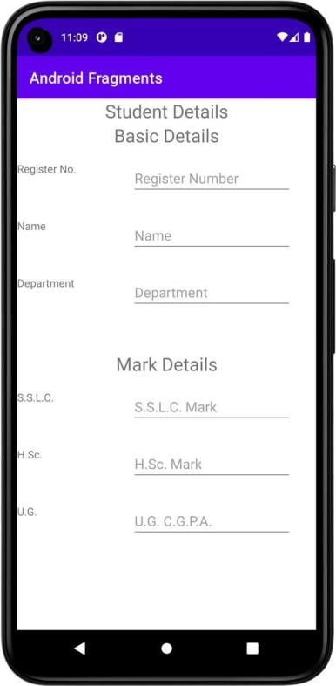

**Result**

|  |  |
| --- | --- |
| **Dept. of Computer Science and Engineering** | **Rajalakshmi Engineering College** | **35** |

|  |  |  |
| --- | --- | --- |
| **Ex. No. :**  **Register No. :** | **05** | **Date :**  **Name :** |
|  |  | **SQLite** |
| **Aim** |  |  |

**36**

Create a Database table with the following structure using SQLite: Student (Register Number, Name, CGPA). Develop an android application to perform the following operation using SQLite developer classes. 1. Insert student Details 2. Update the student Record 3. Delete a specified record. 4. View the details.

# Procedure

**Dept. of Computer Science and Engineering** | **Rajalakshmi Engineering College**

# AndroidManifest.xml



*<?*xml version="1.0" encoding="utf-8"*?>*

<manifest xmlns:android="<http://schemas.android.com/apk/res/android>" xmlns:tools="<http://schemas.android.com/tools>">

<application

android:allowBackup="true" android:dataExtractionRules="@xml/data_extraction_rules" android:fullBackupContent="@xml/backup_rules" android:icon="@mipmap/ic_launcher" android:label="@string/app_name" android:supportsRtl="true" android:theme="@style/Theme.SQLite" tools:targetApi="31">

<activity

android:name=".MainActivity" android:exported="true">

<intent-filter>

<action android:name="android.intent.action.MAIN" />

<category android:name="android.intent.category.LAUNCHER" />

</intent-filter>

</**activity**>

</**application**>

</**manifest**>

**Dept. of Computer Science and Engineering** | **Rajalakshmi Engineering College**

**37**

# activity_main.xml

**38**

*<?*xml version="1.0" encoding="utf-8"*?>*

<LinearLayout xmlns:android="<http://schemas.android.com/apk/res/android>" xmlns:app="<http://schemas.android.com/apk/res-auto>" xmlns:tools="<http://schemas.android.com/tools>" android:layout_width="match_parent" android:layout_height="match_parent"

android:orientation="vertical" tools:context=".MainActivity" >

<TextView

android:id="@+id/tvRegisterNumber" android:layout_width="match_parent" android:layout_height="wrap_content" android:text="Register Number" />

<EditText

android:id="@+id/etRegisterNumber" android:layout_width="match_parent" android:layout_height="wrap_content" android:ems="10" android:inputType="textPersonName" />

<TextView

android:id="@+id/tvName" android:layout_width="match_parent" android:layout_height="wrap_content" android:text="Name" />

<EditText

android:id="@+id/etName" android:layout_width="match_parent" android:layout_height="wrap_content" android:ems="10" android:inputType="textPersonName" />

<TextView

android:id="@+id/tvCGPA" android:layout_width="match_parent" android:layout_height="wrap_content" android:text="CGPA" />

<EditText

android:id="@+id/etCGPA" android:layout_width="match_parent" android:layout_height="wrap_content" android:ems="10" android:inputType="textPersonName" />

<Button

android:id="@+id/btAdd" android:layout_width="match_parent" android:layout_height="wrap_content" android:text="Add" android:textAllCaps="false" />

<Button

android:id="@+id/btView" android:layout_width="match_parent" android:layout_height="wrap_content"

**Dept. of Computer Science and Engineering** | **Rajalakshmi Engineering College**

android:text="View" android:textAllCaps="false" />



<Button

android:id="@+id/btModify" android:layout_width="match_parent" android:layout_height="wrap_content" android:text="Modify" android:textAllCaps="false" />

<Button

android:id="@+id/btDelete" android:layout_width="match_parent" android:layout_height="wrap_content" android:text="Delete" android:textAllCaps="false" />

<Button

android:id="@+id/btClear" android:layout_width="match_parent" android:layout_height="wrap_content" android:text="Clear" android:textAllCaps="false" />

</LinearLayout>

**Dept. of Computer Science and Engineering** | **Rajalakshmi Engineering College**

**39**

# DBContract.kt

**40**

**package** org.rajalakshmi.sqlite

**import** android.provider.BaseColumns

**object** DBContract {

**class** UserEntry : BaseColumns {

companion object {

val TABLE_NAME = "students"

val COLUMN_REGISTER_NUMBER = "registernumber" val COLUMN_NAME = "name"

val COLUMN_CGPA = "cgpa"

}

}

}

# UserModel.kt

**package** org.rajalakshmi.sqlite

**class** UserModel (**val registernumber** : String, **val name** : String, **val cgpa** : String)

**Dept. of Computer Science and Engineering** | **Rajalakshmi Engineering College**

# UsersDBHelper.kt



**package** org.rajalakshmi.sqlite

**import** android.annotation.SuppressLint **import** android.content.ContentValues **import** android.content.Context

**import** android.database.Cursor

**import** android.database.sqlite.SQLiteConstraintException

**import** android.database.sqlite.SQLiteDatabase **import** android.database.sqlite.SQLiteException **import** android.database.sqlite.SQLiteOpenHelper

**class** UsersDBHelper(context: Context) : SQLiteOpenHelper(context, **DATABASE_NAME**, **null**, **DATABASE_VERSION**) {

**override fun** onCreate(db: SQLiteDatabase?) { db?.execSQL(**SQL_CREATE_ENTRIES**)

}

**override fun** onUpgrade(db: SQLiteDatabase?, oldVersion: Int, newVersion: Int) {

db?.execSQL(**SQL_DELETE_ENTRIES**)

onCreate(db)

}

@Throws(SQLiteConstraintException::**class**)

**fun** insertUser(user: UserModel): Boolean {

*// Gets the data repository in write mode*

**val** db = *writableDatabase*

*// Create a new map of values, where column names are the keys* **val** values = ContentValues() values.put(DBContract.UserEntry.**COLUMN_REGISTER_NUMBER**,

user.**registernumber**)

values.put(DBContract.UserEntry.**COLUMN_NAME**, user.**name**) values.put(DBContract.UserEntry.**COLUMN_CGPA**, user.**cgpa**)

*// Insert the new row, returning the primary key value of the new row*

**val** newRowId = db.insert(DBContract.UserEntry.**TABLE_NAME**, **null**, values)

return true

}

@SuppressLint(**"Range"**)

**fun** readUser(registerNumber : String): ArrayList<UserModel> {

**val** users = ArrayList<UserModel>()

**val** db = *writableDatabase* **var** cursor: Cursor? = **null try** {

cursor = db.rawQuery(**"select * from "** + DBContract.UserEntry.**TABLE_NAME** + **" WHERE "** + DBContract.UserEntry.**COLUMN_REGISTER_NUMBER** + **" = '"** + registerNumber + **"'"**, **null**)

}

**catch** (e: SQLiteException) { db.execSQL(**SQL_CREATE_ENTRIES**)

**return** ArrayList()

}

**var** name : String

**var** cgpa : String

**if** (cursor!!.moveToFirst()) {

**Dept. of Computer Science and Engineering** | **Rajalakshmi Engineering College 41**

**while** (cursor.*isAfterLast* == **false**) { name =

cursor.getString(cursor.getColumnIndex(DBContract.UserEntry.**COLUMN_NAME**)) cgpa =

cursor.getString(cursor.getColumnIndex(DBContract.UserEntry.**COLUMN_CGPA**)) users.add(UserModel(registerNumber, name, cgpa)) cursor.moveToNext()

}

}

**return** users

}

@Throws(SQLiteConstraintException::**class**)

**fun** deleteUser(userid: String): Boolean {

**val** db = *writableDatabase*

**val** selection = DBContract.UserEntry.**COLUMN_REGISTER_NUMBER** + **" LIKE ?" val** selectionArgs = *arrayOf*(userid) db.delete(DBContract.UserEntry.**TABLE_NAME**, selection, selectionArgs) **return true**

}

companion object {

*// If you change the database schema, you must increment the database*

*version.*

KEY," +

val DATABASE_VERSION = 1

val DATABASE_NAME = "FeedReader.db"

private val SQL_CREATE_ENTRIES =

**"CREATE TABLE "** + DBContract.UserEntry.**TABLE_NAME** + **" ("** + DBContract.UserEntry.**COLUMN_REGISTER_NUMBER** + **" TEXT PRIMARY**

DBContract.UserEntry.**COLUMN_NAME** + **" TEXT,"** + DBContract.UserEntry.**COLUMN_CGPA** + **" TEXT)"**

private val SQL_DELETE_ENTRIES = "DROP TABLE IF EXISTS " +

DBContract.UserEntry.**TABLE_NAME**

**42**

}

}

**Dept. of Computer Science and Engineering** | **Rajalakshmi Engineering College**

# MainActivity.kt



**package** org.rajalakshmi.sqlite

**import** android.database.sqlite.SQLiteConstraintException

**import** androidx.appcompat.app.AppCompatActivity

**import** android.os.Bundle **import** android.widget.Button **import** android.widget.EditText **import** android.widget.Toast

**class** MainActivity : AppCompatActivity() {

**lateinit var usersDBHelper** : UsersDBHelper

**override fun** onCreate(savedInstanceState: Bundle?) { **super**.onCreate(savedInstanceState) setContentView(R.layout.*activity_main*)

**val** etRegisterNumber : EditText = findViewById(R.id.*etRegisterNumber*)

**val** etName : EditText = findViewById(R.id.*etName*) **val** etCGPA : EditText = findViewById(R.id.*etCGPA*) **val** btAdd : Button = findViewById(R.id.*btAdd*)

**val** btView : Button = findViewById(R.id.*btView*)

**val** btModify : Button = findViewById(R.id.*btModify*) **val** btDelete : Button = findViewById(R.id.*btDelete*) **val** btClear : Button = findViewById(R.id.*btClear*) **usersDBHelper** = UsersDBHelper(**this**) btAdd.setOnClickListener **{**

**val** registerNumber : String = etRegisterNumber.*text*.toString()

**val** name : String = etName.*text*.toString()

**val** cgpa : String = etCGPA.*text*.toString()

**var** result = **usersDBHelper**.insertUser(UserModel(registernumber = registerNumber, name = name, cgpa = cgpa))

etRegisterNumber.setText(**""**) etName.setText(**""**) etCGPA.setText(**""**)

**}**

btView.setOnClickListener **{**

**var** users = **usersDBHelper**.readUser(etRegisterNumber.*text*.toString()) users.*forEach* **{**

etName.setText(**it**.**name**) etCGPA.setText(**it**.**cgpa**)

**}**

**}**

btDelete.setOnClickListener **{**

**var** registerNumber = etRegisterNumber.*text*.toString() **val** result = **usersDBHelper**.deleteUser(registerNumber) **if**(result)

Toast.makeText(*applicationContext*, **"User Deleted...!"**, Toast.*LENGTH_LONG*).show()

**}**

btClear.setOnClickListener **{** etRegisterNumber.setText(**""**) etName.setText(**""**) etCGPA.setText(**""**)

**}**

}

}

**Dept. of Computer Science and Engineering** | **Rajalakshmi Engineering College**

**43**

# Output

**44**

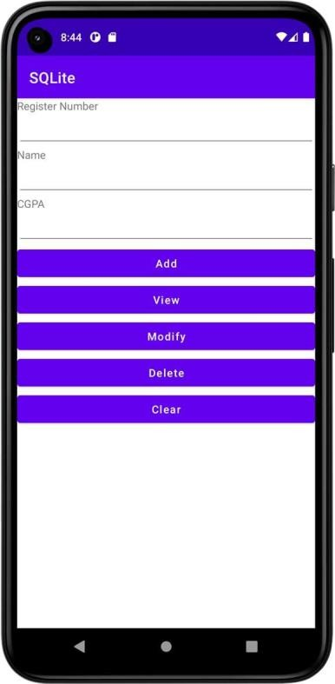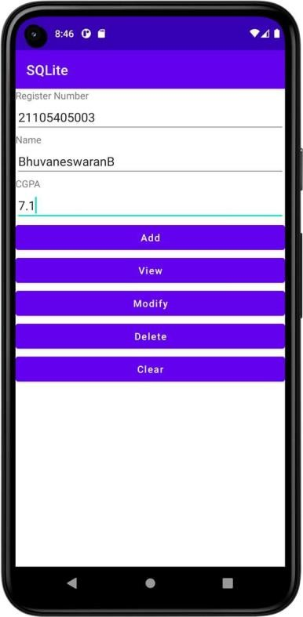

**Dept. of Computer Science and Engineering** | **Rajalakshmi Engineering College**

**Ex. No. : 06 Date :**



**Register No. : Name :**

**Form Validation**

**Aim**

Design an android activity with two text boxes where the user can enter (username and ID) and a button (validate). Validate the entered username and ID field for the following using android code. i) Both the fields should not be empty ii) Name field should have alphabets iii) ID field should have numeric values (only 4-digit).

# Procedure

**Dept. of Computer Science and Engineering** | **Rajalakshmi Engineering College**

**45**

# AndroidManifest.xml

**46**

*<?*xml version="1.0" encoding="utf-8"*?>*

<manifest xmlns:android="<http://schemas.android.com/apk/res/android>" xmlns:tools="<http://schemas.android.com/tools>">

<application

android:allowBackup="true" android:dataExtractionRules="@xml/data_extraction_rules" android:fullBackupContent="@xml/backup_rules" android:icon="@mipmap/ic_launcher" android:label="@string/app_name" android:supportsRtl="true" android:theme="@style/Theme.FormValidation" tools:targetApi="31">

<activity

android:name=".MainActivity2" android:exported="false" />

<activity

android:name=".MainActivity" android:exported="true">

<intent-filter>

<action android:name="android.intent.action.MAIN" />

<category android:name="android.intent.category.LAUNCHER" />

</intent-filter>

</**activity**>

</**application**>

</**manifest**>

**Dept. of Computer Science and Engineering** | **Rajalakshmi Engineering College**

# activity_main.xml



*<?*xml version="1.0" encoding="utf-8"*?>*

<LinearLayout xmlns:android="<http://schemas.android.com/apk/res/android>" xmlns:app="<http://schemas.android.com/apk/res-auto>" xmlns:tools="<http://schemas.android.com/tools>" android:layout_width="match_parent" android:layout_height="match_parent"

android:orientation="vertical" tools:context=".MainActivity">

<EditText

android:id="@+id/etUserName" android:layout_width="match_parent" android:layout_height="wrap_content" android:ems="10"

android:hint="Enter the userame...!" android:inputType="textPersonName" />

<EditText

android:id="@+id/etPinNumber" android:layout_width="match_parent" android:layout_height="wrap_content" android:ems="10"

android:hint="Enter the pin number...!" android:inputType="textPersonName" />

<Button

android:id="@+id/btLogin" android:layout_width="match_parent" android:layout_height="wrap_content" android:text="Login" android:textAllCaps="false" />

<Button

android:id="@+id/btClear" android:layout_width="match_parent" android:layout_height="wrap_content" android:text="Clear" android:textAllCaps="false" />

</LinearLayout>

**Dept. of Computer Science and Engineering** | **Rajalakshmi Engineering College**

**47**

# activity_main2.xml

**48**

*<?*xml version="1.0" encoding="utf-8"*?>*

<LinearLayout xmlns:android="<http://schemas.android.com/apk/res/android>" xmlns:app="<http://schemas.android.com/apk/res-auto>" xmlns:tools="<http://schemas.android.com/tools>" android:layout_width="match_parent" android:layout_height="match_parent"

android:orientation="vertical" tools:context=".MainActivity2">

<TextView

android:id="@+id/tvLoginSuccess" android:layout_width="match_parent" android:layout_height="wrap_content" android:text="Login Success...!" android:textAlignment="center" android:textSize="24sp" />

</LinearLayout>

**Dept. of Computer Science and Engineering** | **Rajalakshmi Engineering College**

# MainActivity.kt



**package** org.rajalakshmi.formvalidation

**import** android.content.Intent

**import** androidx.appcompat.app.AppCompatActivity

**import** android.os.Bundle **import** android.widget.Button **import** android.widget.EditText **import** android.widget.Toast

**class** MainActivity : AppCompatActivity() {

**override fun** onCreate(savedInstanceState: Bundle?) { **super**.onCreate(savedInstanceState) setContentView(R.layout.*activity_main*)

**val** etUserName : EditText = findViewById(R.id.*etUserName*) **val** etPinNumber : EditText = findViewById(R.id.*etPinNumber*) **val** btLogin : Button = findViewById(R.id.*btLogin*)

**val** btClear : Button = findViewById(R.id.*btClear*)

btLogin.setOnClickListener **{**

**val** checkUserName = **"[a-zA-Z]+"**.*toRegex*() **val** checkPinNo = **"[0-9]{4}"**.*toRegex*()

**if**(checkUserName.matches(etUserName.*text*.toString()) && checkPinNo.matches(etPinNumber.*text*.toString())) {

**val** intent = Intent(**this**, MainActivity2::**class**.*java*) startActivity(intent)

}

else {

Toast.makeText(*applicationContext*, **"Invalid User Name / Pin No."**,Toast.*LENGTH_LONG*).show()

}

**}**

btClear.setOnClickListener **{** etUserName.*text*.clear() etPinNumber.*text*.clear()

**}**

}

}

**Dept. of Computer Science and Engineering** | **Rajalakshmi Engineering College 49**

# MainActivity2.kt

**50**

**package** org.rajalakshmi.formvalidation

**import** androidx.appcompat.app.AppCompatActivity

**import** android.os.Bundle

**class** MainActivity2 : AppCompatActivity() {

**override fun** onCreate(savedInstanceState: Bundle?) { **super**.onCreate(savedInstanceState) setContentView(R.layout.*activity_main2*)

}

}

**Dept. of Computer Science and Engineering** | **Rajalakshmi Engineering College**

# Output

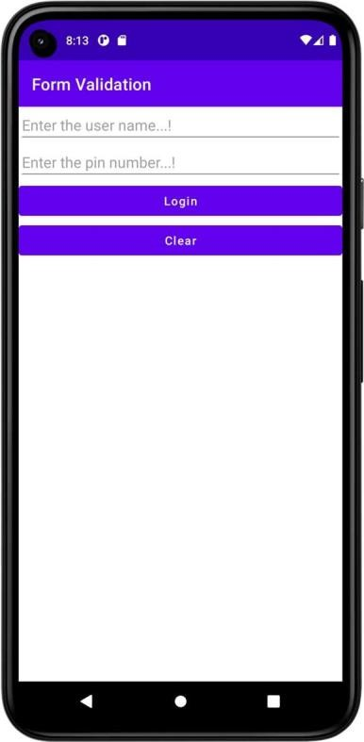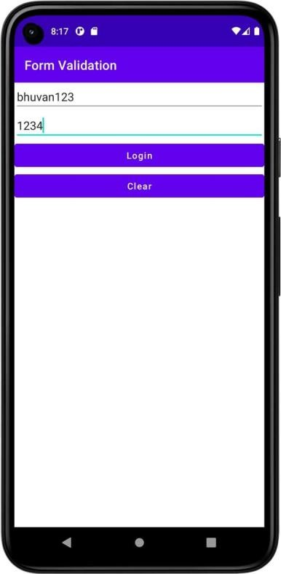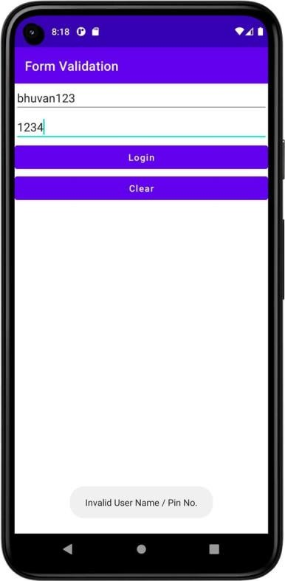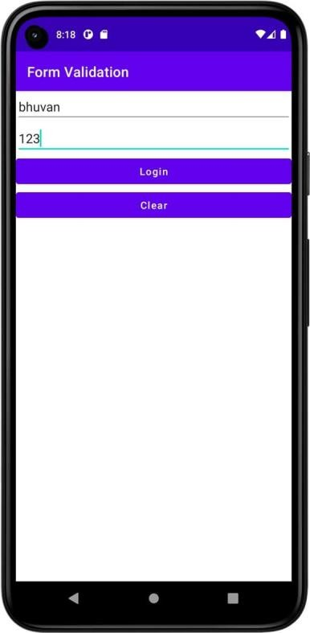

**Dept. of Computer Science and Engineering** | **Rajalakshmi Engineering College**

**51**

**52**

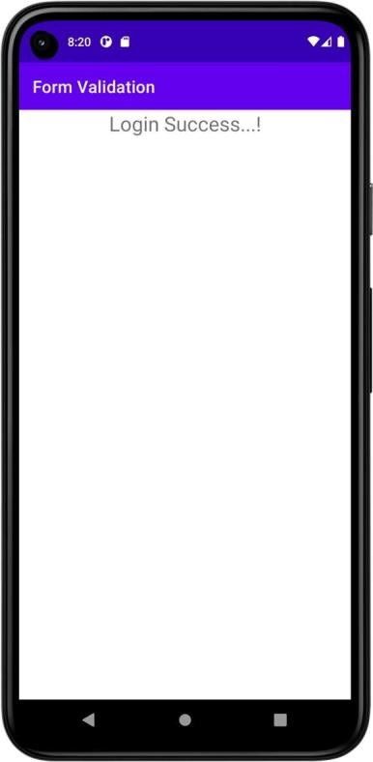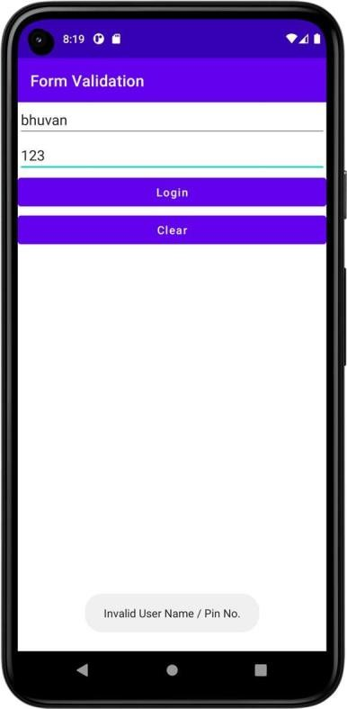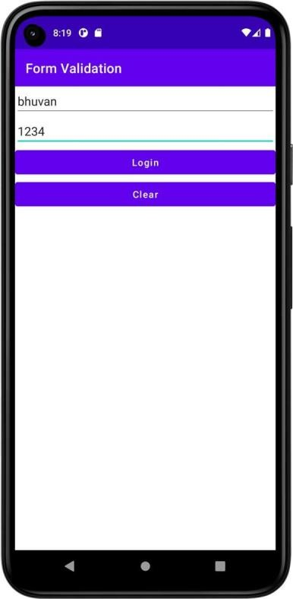

# Result

**Dept. of Computer Science and Engineering** | **Rajalakshmi Engineering College**

|  |  |  |
| --- | --- | --- |
| **Ex. No. :**  **Register No. :** | **07** | **Date :**  **Name :** |
|  |  | **SD Card** |
| **Aim** |  |  |



Implement an application to write the Register Number, Name and CGPA to SD card in text file format.

# Procedure

**Dept. of Computer Science and Engineering** | **Rajalakshmi Engineering College**

**53**

# AndroidManifest.xml

**54**

*<?*xml version="1.0" encoding="utf-8"*?>*

<manifest xmlns:android="<http://schemas.android.com/apk/res/android>" xmlns:tools="<http://schemas.android.com/tools>">

<uses-permission android:name="android.permission.WRITE_EXTERNAL_STORAGE"/>

<uses-permission android:name="android.permission.READ_EXTERNAL_STORAGE"/>

<application

android:allowBackup="true" android:dataExtractionRules="@xml/data_extraction_rules" android:fullBackupContent="@xml/backup_rules" android:icon="@mipmap/ic_launcher" android:label="@string/app_name" android:supportsRtl="true" android:theme="@style/Theme.SDCard" tools:targetApi="31">

<activity

android:name=".MainActivity" android:exported="true">

<intent-filter>

<action android:name="android.intent.action.MAIN" />

<category android:name="android.intent.category.LAUNCHER" />

</intent-filter>

</**activity**>

</**application**>

</**manifest**>

**Dept. of Computer Science and Engineering** | **Rajalakshmi Engineering College**

# activity_main.xml



*<?*xml version="1.0" encoding="utf-8"*?>*

<LinearLayout xmlns:android="<http://schemas.android.com/apk/res/android>" xmlns:app="<http://schemas.android.com/apk/res-auto>" xmlns:tools="<http://schemas.android.com/tools>" android:layout_width="match_parent" android:layout_height="match_parent"

android:orientation="vertical" tools:context=".MainActivity">

<EditText

android:id="@+id/etRegisterNumber" android:layout_width="match_parent" android:layout_height="wrap_content" android:ems="10"

android:hint="Enter the register number...!" android:inputType="textPersonName" />

<EditText

android:id="@+id/etName" android:layout_width="match_parent" android:layout_height="wrap_content" android:ems="10" android:hint="Enter the name...!"

android:inputType="textPersonName" />

<EditText

android:id="@+id/etCGPA" android:layout_width="match_parent" android:layout_height="wrap_content" android:ems="10" android:hint="Enter the CGPA...!"

android:inputType="textPersonName" />

<Button

android:id="@+id/btSave" android:layout_width="match_parent" android:layout_height="wrap_content" android:text="Save" android:textAllCaps="false" />

<Button

android:id="@+id/btLoad" android:layout_width="match_parent" android:layout_height="wrap_content" android:text="Load" android:textAllCaps="false" />

</LinearLayout>

**Dept. of Computer Science and Engineering** | **Rajalakshmi Engineering College**

**55**

# MainActivity.kt

**56**

**package** org.rajalakshmi.sdcard

**import** androidx.appcompat.app.AppCompatActivity

**import** android.os.Bundle **import** android.widget.Button **import** android.widget.EditText **import** java.io.*

**class** MainActivity : AppCompatActivity() {

**override fun** onCreate(savedInstanceState: Bundle?) { **super**.onCreate(savedInstanceState) setContentView(R.layout.*activity_main*)

**val** etRegisterNumber : EditText = findViewById(R.id.*etRegisterNumber*)

**val** etName : EditText = findViewById(R.id.*etName*) **val** etCGPA : EditText = findViewById(R.id.*etCGPA*) **val** btSave : Button = findViewById(R.id.*btSave*) **val** btLoad : Button = findViewById(R.id.*btLoad*)

btSave.setOnClickListener **{**

**val** registerNumber = etRegisterNumber.*text*.toString()

**val** name = etName.*text*.toString()

**val** cgpa = etCGPA.*text*.toString()

**val** file = File(getExternalFilesDir(**null**), **"student.txt"**) **val** outputStream = FileOutputStream(file, **false**)

outputStream.write(**"$**registerNumber**,$**name**,$**cgpa**\n"**.*toByteArray*()) outputStream.close()

etRegisterNumber.*text*.clear() etName.*text*.clear() etCGPA.*text*.clear()

**}**

btLoad.setOnClickListener **{**

**val** file = File(getExternalFilesDir(**null**), **"student.txt"**) **val** inputStream = FileInputStream(file)

**val** inputStreamReader = InputStreamReader(inputStream) **val** bufferedReader = BufferedReader(inputStreamReader) **var** line: String

line = bufferedReader.readLine() **val** parts = line.*split*(**","**) etRegisterNumber.setText(parts[0]) etName.setText(parts[1]) etCGPA.setText(parts[2]) inputStream.close()

**}**

}

}

**Dept. of Computer Science and Engineering** | **Rajalakshmi Engineering College**

# Output

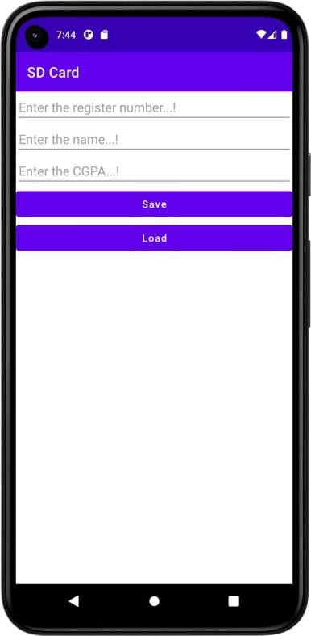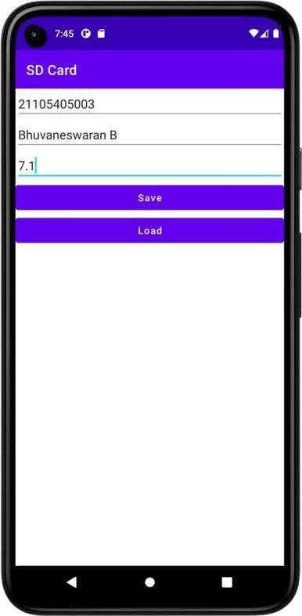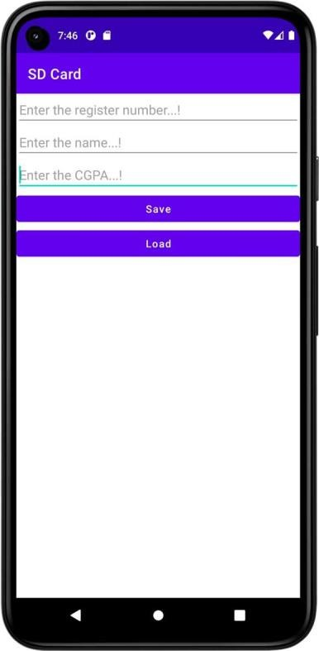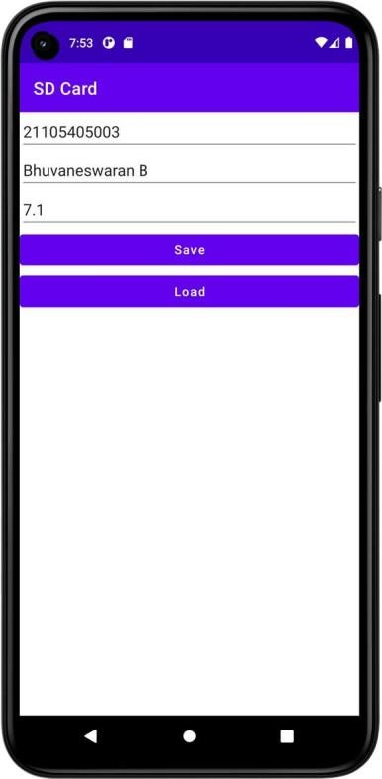

**Result**

**Dept. of Computer Science and Engineering** | **Rajalakshmi Engineering College**

**57**

**Ex. No. : 08 Date :**

**58**

**Register No. : Name :**

**Alert Dialog Box**

**Aim**

Implement an application to display the alert box message.

# Procedure

**Dept. of Computer Science and Engineering** | **Rajalakshmi Engineering College**

# AndroidManifest.xml



*<?*xml version="1.0" encoding="utf-8"*?>*

<manifest xmlns:android="<http://schemas.android.com/apk/res/android>" xmlns:tools="<http://schemas.android.com/tools>">

<application

android:allowBackup="true" android:dataExtractionRules="@xml/data_extraction_rules" android:fullBackupContent="@xml/backup_rules" android:icon="@mipmap/ic_launcher" android:label="@string/app_name" android:supportsRtl="true" android:theme="@style/Theme.AlertDialogBox" tools:targetApi="31">

<activity

android:name=".MainActivity" android:exported="true">

<intent-filter>

<action android:name="android.intent.action.MAIN" />

<category android:name="android.intent.category.LAUNCHER" />

</intent-filter>

</**activity**>

</**application**>

</**manifest**>

**Dept. of Computer Science and Engineering** | **Rajalakshmi Engineering College**

**59**

# activity_main.xml

**60**

*<?*xml version="1.0" encoding="utf-8"*?>*

<LinearLayout xmlns:android="<http://schemas.android.com/apk/res/android>" xmlns:app="<http://schemas.android.com/apk/res-auto>" xmlns:tools="<http://schemas.android.com/tools>" android:layout_width="match_parent" android:layout_height="match_parent"

android:orientation="vertical" tools:context=".MainActivity">

<EditText

android:id="@+id/etText" android:layout_width="match_parent" android:layout_height="wrap_content" android:ems="10" android:hint="Enter the text...!"

android:inputType="textPersonName" />

<Button

android:id="@+id/btDisplay" android:layout_width="match_parent" android:layout_height="wrap_content" android:text="Display" android:textAllCaps="false" />

</LinearLayout>

**Dept. of Computer Science and Engineering** | **Rajalakshmi Engineering College**

# MainActivity.kt



**package** org.rajalakshmi.alertdialogbox

**import** androidx.appcompat.app.AppCompatActivity

**import** android.os.Bundle **import** android.widget.Button **import** android.widget.EditText **import** android.widget.Toast

**import** androidx.appcompat.app.AlertDialog

**class** MainActivity : AppCompatActivity() {

**override fun** onCreate(savedInstanceState: Bundle?) { **super**.onCreate(savedInstanceState) setContentView(R.layout.*activity_main*)

**val** etText : EditText = findViewById(R.id.*etText*)

**val** btDisplay : Button = findViewById(R.id.*btDisplay*)

btDisplay.setOnClickListener **{**

**val** alertDialog = AlertDialog.Builder(**this**)

.setTitle(**"MAD Lab"**)

.setMessage(etText.*text*.toString())

.setPositiveButton(**"OK"**) **{** dialog, which **->**

Toast.makeText(*applicationContext*, **"You clicked OK"**, Toast.*LENGTH_LONG*).show()

**}**

.setNegativeButton(**"Cancel"**) **{** dialog, which **->**

Toast.makeText(*applicationContext*, **"You clicked Cancel"**, Toast.*LENGTH_LONG*).show()

**}**

.create() alertDialog.show()

**}**

}

}

**Dept. of Computer Science and Engineering** | **Rajalakshmi Engineering College**

**61**

# Output

**62**

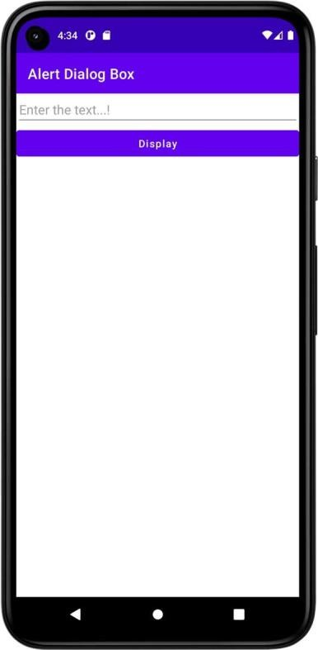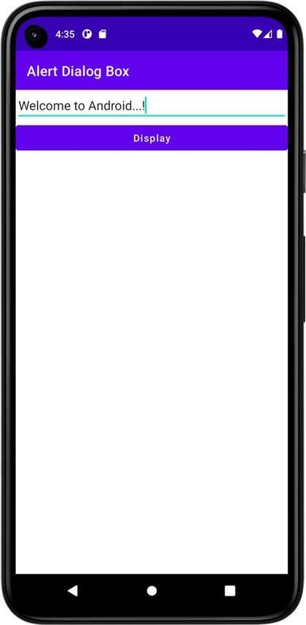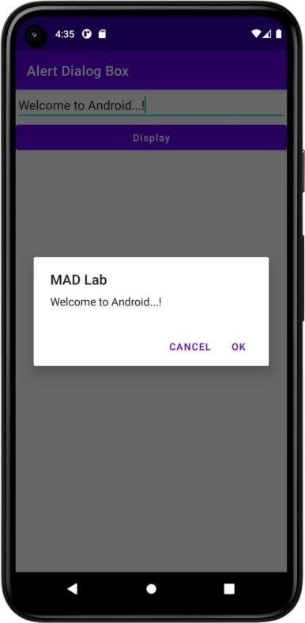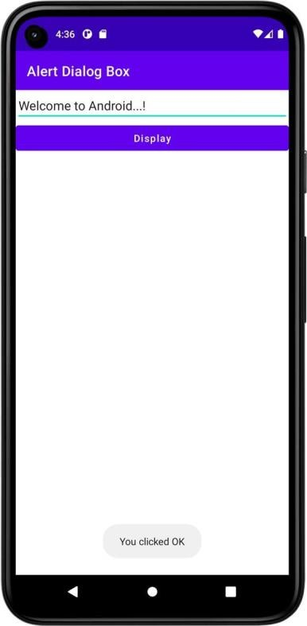

**Dept. of Computer Science and Engineering** | **Rajalakshmi Engineering College**

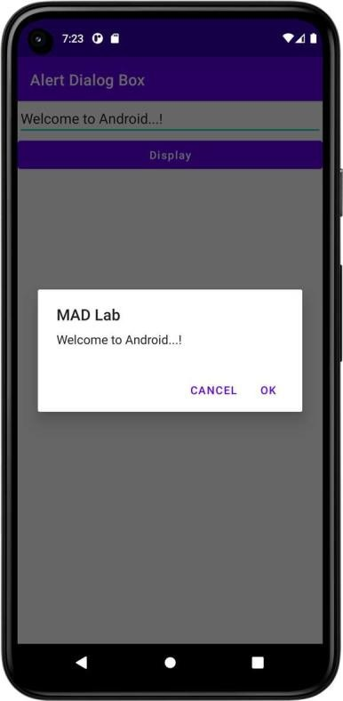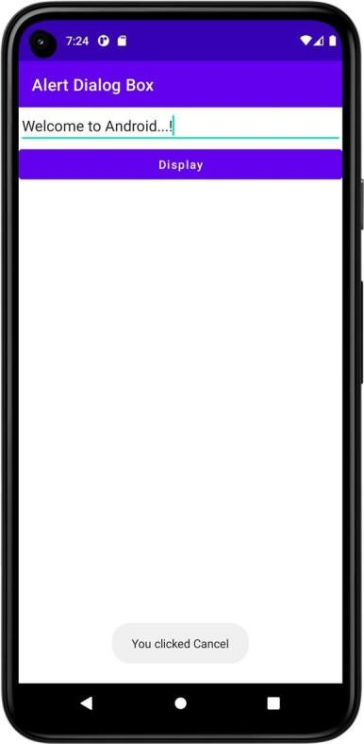

# Result

**Dept. of Computer Science and Engineering** | **Rajalakshmi Engineering College**

**63**

**Ex. No. : 09 Date :**

**64**

**Register No. : Name :**

**Alarm**

**Aim**

Write a mobile application to set the alarm using android Alarm Manager class.

# Procedure

**Dept. of Computer Science and Engineering** | **Rajalakshmi Engineering College**

# AndroidManifest.xml



*<?*xml version="1.0" encoding="utf-8"*?>*

<manifest xmlns:android="<http://schemas.android.com/apk/res/android>" xmlns:tools="<http://schemas.android.com/tools>">

<uses-permission android:name="android.permission.SCHEDULE_EXACT_ALARM"/>

<application

android:allowBackup="true" android:dataExtractionRules="@xml/data_extraction_rules" android:fullBackupContent="@xml/backup_rules" android:icon="@mipmap/ic_launcher" android:label="@string/app_name" android:supportsRtl="true" android:theme="@style/Theme.MyApplication" tools:targetApi="31">

<activity

android:name=".MainActivity" android:exported="true">

<intent-filter>

<action android:name="android.intent.action.MAIN" />

<category android:name="android.intent.category.LAUNCHER" />

</intent-filter>

</**activity**>

<receiver android:name=".AlarmReceiver">

</**receiver**>

</**application**>

</**manifest**>

**Dept. of Computer Science and Engineering** | **Rajalakshmi Engineering College**

**65**

# activity_main.xml

**66**

*<?*xml version="1.0" encoding="utf-8"*?>*

<LinearLayout xmlns:android="<http://schemas.android.com/apk/res/android>" xmlns:app="<http://schemas.android.com/apk/res-auto>" xmlns:tools="<http://schemas.android.com/tools>" android:layout_width="match_parent" android:layout_height="match_parent"

android:orientation="vertical" tools:context=".MainActivity">

<TimePicker

android:id="@+id/timePicker" android:layout_width="match_parent" android:layout_height="wrap_content" android:layout_gravity="center" />

<Button

android:id="@+id/btSetAlarm" android:layout_width="match_parent" android:layout_height="wrap_content" android:text="Set Alarm" android:textAllCaps="false" />

<Button

android:id="@+id/btnStopAlarm" android:layout_width="match_parent" android:layout_height="wrap_content" android:text="Stop Alarm" android:textAllCaps="false" />

</LinearLayout>

**Dept. of Computer Science and Engineering** | **Rajalakshmi Engineering College**

# MainActivity.kt



**package** org.rajalakshmi.myapplication

**import** android.app.AlarmManager **import** android.app.PendingIntent **import** android.content.Intent

**import** androidx.appcompat.app.AppCompatActivity

**import** android.os.Bundle

**import** android.widget.Button **import** android.widget.TimePicker **import** android.widget.Toast **import** java.util.*

**class** MainActivity : AppCompatActivity() { **lateinit var pendingIntent**: PendingIntent **private lateinit var alarmManager**: AlarmManager

**override fun** onCreate(savedInstanceState: Bundle?) {

**super**.onCreate(savedInstanceState) setContentView(R.layout.*activity_main*)

**val** alarmTimePicker: TimePicker = findViewById(R.id.*timePicker*)

**val** btSetAlarm : Button = findViewById(R.id.*btSetAlarm*)

**val** btStopAlarm : Button = findViewById(R.id.*btnStopAlarm*)

**alarmManager** = getSystemService(*ALARM_SERVICE*) **as** AlarmManager

btSetAlarm.setOnClickListener **{**

Toast.makeText(*applicationContext*, **"Alarm ON...!"**, Toast.*LENGTH_LONG*).show()

**val** calendar: Calendar = Calendar.getInstance() calendar.set(Calendar.*HOUR_OF_DAY*, alarmTimePicker.*hour*) calendar.set(Calendar.*MINUTE*, alarmTimePicker.*minute*) **val** intent = Intent(**this**, AlarmReceiver::**class**.*java*)

**pendingIntent** = PendingIntent.getBroadcast(**this**.*applicationContext*, 2, intent, PendingIntent.*FLAG_CANCEL_CURRENT*)

**val** time:Long = calendar.*timeInMillis* - (calendar.*timeInMillis* %

60000)

**alarmManager**.setRepeating(AlarmManager.*RTC_WAKEUP*, time, 10000,

pendingIntent)

**}**

btStopAlarm.setOnClickListener **{ alarmManager**.cancel(**pendingIntent**) Toast.makeText(*applicationContext*, **"Alarm OFF...!"**,

Toast.*LENGTH_LONG*).show()

**}**

}

}

**Dept. of Computer Science and Engineering** | **Rajalakshmi Engineering College**

**67**

# AlarmReceiver.kt

**68**

**package** org.rajalakshmi.myapplication

**import** android.content.BroadcastReceiver

**import** android.content.Context **import** android.content.Intent **import** android.media.Ringtone **import** android.media.RingtoneManager **import** android.net.Uri

**import** android.widget.Toast

**class** AlarmReceiver : BroadcastReceiver() {

**override fun** onReceive(context: Context?, intent: Intent?) { Toast.makeText(context, **"Alarm Ringing...!"**, Toast.*LENGTH_LONG*).show() **var** ringtone: Ringtone

**val** alarmUri: Uri = RingtoneManager.getDefaultUri(RingtoneManager.*TYPE_ALARM*)

ringtone = RingtoneManager.getRingtone(context, alarmUri) ringtone.play()

}

}

**Dept. of Computer Science and Engineering** | **Rajalakshmi Engineering College**

# Output

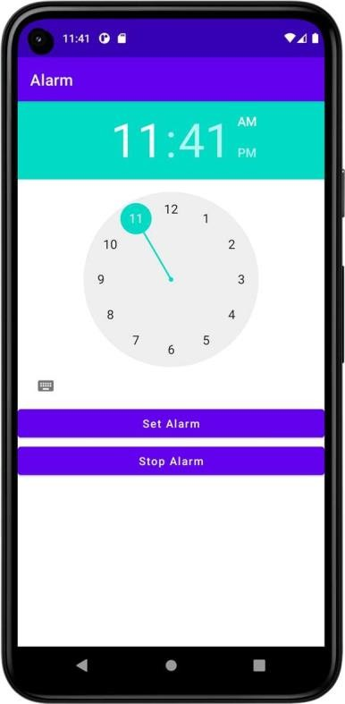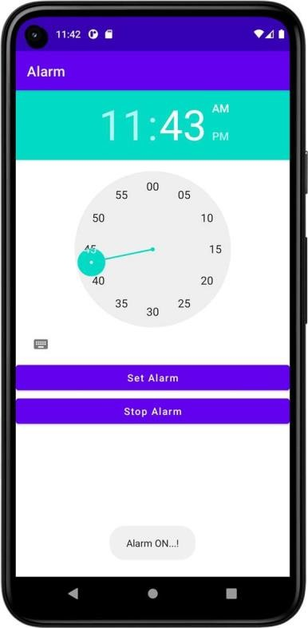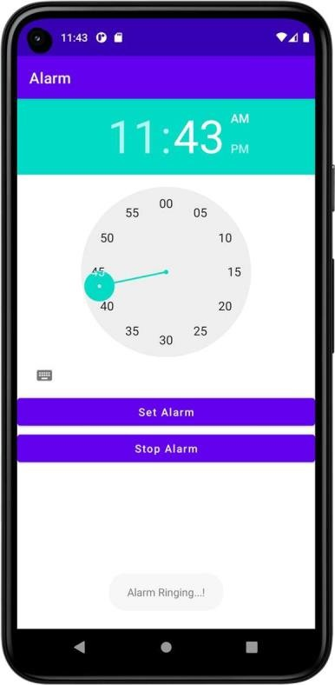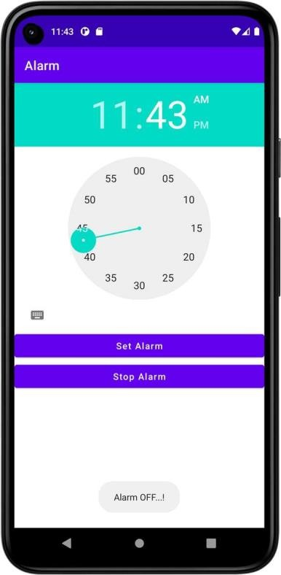

**Dept. of Computer Science and Engineering** | **Rajalakshmi Engineering College**

**69**

**Ex. No. : 10 Date :**

**70**

**Register No. : Name :**

**Telephony Services**

**Aim**

Develop an android application to display the information of the telephony services.

# Procedure

**Dept. of Computer Science and Engineering** | **Rajalakshmi Engineering College**

# AndroidManifest.xml



*<?*xml version="1.0" encoding="utf-8"*?>*

<manifest xmlns:android="<http://schemas.android.com/apk/res/android>" xmlns:tools="<http://schemas.android.com/tools>">

<uses-permission android:name="android.permission.READ_PHONE_STATE"/>

<application

android:allowBackup="true" android:dataExtractionRules="@xml/data_extraction_rules" android:fullBackupContent="@xml/backup_rules" android:icon="@mipmap/ic_launcher" android:label="@string/app_name" android:supportsRtl="true" android:theme="@style/Theme.TelephonyServices" tools:targetApi="31">

<activity

android:name=".MainActivity" android:exported="true">

<intent-filter>

<action android:name="android.intent.action.MAIN" />

<category android:name="android.intent.category.LAUNCHER" />

</intent-filter>

</**activity**>

</**application**>

</**manifest**>

**Dept. of Computer Science and Engineering** | **Rajalakshmi Engineering College**

**71**

# activity_main.xml

**72**

*<?*xml version="1.0" encoding="utf-8"*?>*

<LinearLayout xmlns:android="<http://schemas.android.com/apk/res/android>" xmlns:app="<http://schemas.android.com/apk/res-auto>" xmlns:tools="<http://schemas.android.com/tools>" android:layout_width="match_parent" android:layout_height="match_parent"

android:orientation="vertical" tools:context=".MainActivity">

<TextView

android:id="@+id/tvNetworkOperatorName" android:layout_width="match_parent" android:layout_height="wrap_content" android:text="Network Operator Name" />

<EditText

android:id="@+id/etNetworkOperatorName" android:layout_width="match_parent" android:layout_height="wrap_content" android:ems="10" android:inputType="textPersonName" />

<TextView

android:id="@+id/tvPhoneType" android:layout_width="match_parent" android:layout_height="wrap_content" android:text="Phone Type" />

<EditText

android:id="@+id/etPhoneType" android:layout_width="match_parent" android:layout_height="wrap_content" android:ems="10" android:inputType="textPersonName" />

<TextView

android:id="@+id/tvNetworkCountryISO" android:layout_width="match_parent" android:layout_height="wrap_content" android:text="Network Country ISO" />

<EditText

android:id="@+id/etNetworkCountryISO" android:layout_width="match_parent" android:layout_height="wrap_content" android:ems="10" android:inputType="textPersonName" />

<TextView

android:id="@+id/tvSIMCountryISO" android:layout_width="match_parent" android:layout_height="wrap_content" android:text="SIM Country ISO" />

<EditText

android:id="@+id/etSIMCountryISO" android:layout_width="match_parent" android:layout_height="wrap_content" android:ems="10"

**Dept. of Computer Science and Engineering** | **Rajalakshmi Engineering College**

android:inputType="textPersonName" />



<TextView

android:id="@+id/tvDeviceSoftwareVersion" android:layout_width="match_parent" android:layout_height="wrap_content" android:text="Device Software Version" />

<EditText

android:id="@+id/etDeviceSoftwareVersion" android:layout_width="match_parent" android:layout_height="wrap_content" android:ems="10" android:inputType="textPersonName" />

<Button

android:id="@+id/btGetTelephonyServices" android:layout_width="match_parent" android:layout_height="wrap_content" android:text="Get Telephony Services" android:textAllCaps="false" />

</LinearLayout>

**Dept. of Computer Science and Engineering** | **Rajalakshmi Engineering College**

**73**

# MainActivity.kt

**74**

**package** org.rajalakshmi.telephonyservices

**import** android.content.Context

**import** android.content.pm.PackageManager **import** androidx.appcompat.app.AppCompatActivity **import** android.os.Bundle

**import** android.telephony.TelephonyManager

**import** android.widget.Button

**import** android.widget.EditText

**import** androidx.core.app.ActivityCompat

**class** MainActivity : AppCompatActivity() {

private val REQUEST_CODE_PHONE_STATE = 1000

**override fun** onCreate(savedInstanceState: Bundle?) { **super**.onCreate(savedInstanceState) setContentView(R.layout.*activity_main*)

**val** etNetworkOperatorName : EditText = findViewById(R.id.*etNetworkOperatorName*)

**val** etPhoneType : EditText = findViewById(R.id.*etPhoneType*)

**val** etNetworkCountryISO : EditText = findViewById(R.id.*etNetworkCountryISO*)

**val** etSIMCountryISO : EditText = findViewById(R.id.*etSIMCountryISO*)

**val** etDeviceSoftwareVersion : EditText = findViewById(R.id.*etDeviceSoftwareVersion*)

**val** btGetTelephonyServices : Button = findViewById(R.id.*btGetTelephonyServices*)

**val** telephonyManager = getSystemService(Context.*TELEPHONY_SERVICE*) **as**

TelephonyManager

**if** (ActivityCompat.checkSelfPermission(**this**, android.Manifest.permission.*READ_PHONE_STATE*) != PackageManager.*PERMISSION_GRANTED* ) {

ActivityCompat.requestPermissions(**this**,

*arrayOf*(android.Manifest.permission.*READ_PHONE_STATE*), **REQUEST_CODE_PHONE_STATE**)

}

btGetTelephonyServices.setOnClickListener **{**

**val** networkOperatorName = telephonyManager.*networkOperatorName*

**val** phoneType: Int = telephonyManager.getPhoneType()

**var** strphoneType : String = **"" val** networkCountryISO: String =

telephonyManager.getNetworkCountryIso()

**val** SIMCountryISO: String = telephonyManager.getSimCountryIso()

**val** deviceSoftwareVersion: String? = telephonyManager.getDeviceSoftwareVersion()

**when** (phoneType) {

TelephonyManager.*PHONE_TYPE_CDMA* -> strphoneType = **"CDMA"** TelephonyManager.*PHONE_TYPE_GSM* -> strphoneType = **"GSM"** TelephonyManager.*PHONE_TYPE_NONE* -> strphoneType = **"NONE"**

}

etNetworkOperatorName.setText(networkOperatorName) etPhoneType.setText(strphoneType) etNetworkCountryISO.setText(networkCountryISO) etSIMCountryISO.setText(SIMCountryISO) etDeviceSoftwareVersion.setText(deviceSoftwareVersion)

**}**

}

}

**Dept. of Computer Science and Engineering** | **Rajalakshmi Engineering College**

# Output

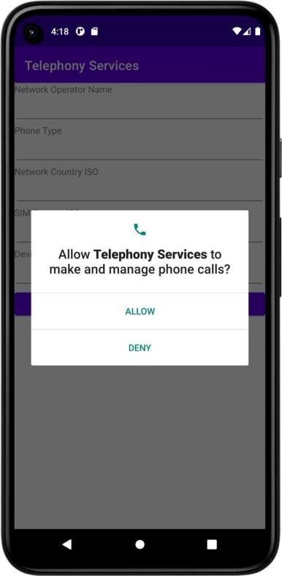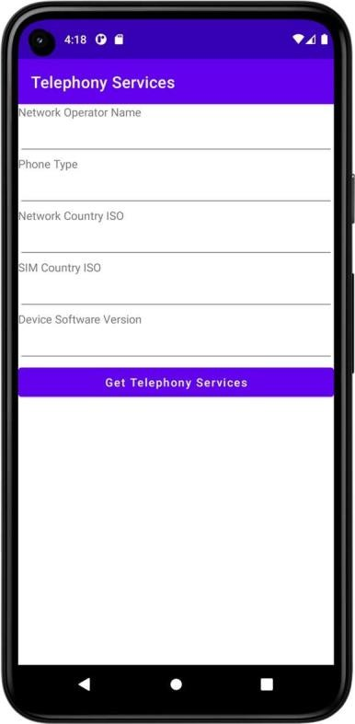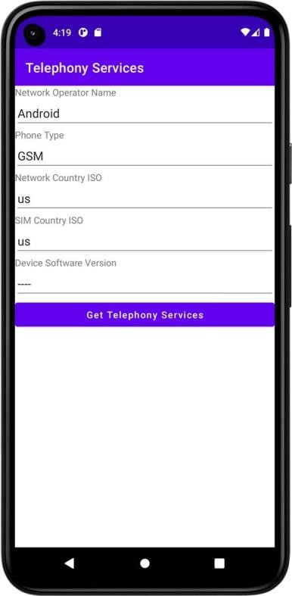

**Result**

**Dept. of Computer Science and Engineering** | **Rajalakshmi Engineering College**

**75**

|  |  |  |
| --- | --- | --- |
| **Ex. No. :**  **Register No. :** | **11** | **Date :**  **Name :** |
|  |  | **Send SMS** |
| **Aim** |  |  |

**76**

Develop an application to send SMS.

# Procedure

**Dept. of Computer Science and Engineering** | **Rajalakshmi Engineering College**

# AndroidManifest.xml



*<?*xml version="1.0" encoding="utf-8"*?>*

<manifest xmlns:android="<http://schemas.android.com/apk/res/android>" xmlns:tools="<http://schemas.android.com/tools>">

<uses-permission android:name="android.permission.SEND_SMS"/>

<application

android:allowBackup="true" android:dataExtractionRules="@xml/data_extraction_rules" android:fullBackupContent="@xml/backup_rules" android:icon="@mipmap/ic_launcher" android:label="@string/app_name" android:supportsRtl="true" android:theme="@style/Theme.SendSMS" tools:targetApi="31">

<activity

android:name=".MainActivity" android:exported="true">

<intent-filter>

<action android:name="android.intent.action.MAIN" />

<category android:name="android.intent.category.LAUNCHER" />

</intent-filter>

</**activity**>

</**application**>

</**manifest**>

**Dept. of Computer Science and Engineering** | **Rajalakshmi Engineering College**

**77**

# activity_main.xml

**78**

*<?*xml version="1.0" encoding="utf-8"*?>*

<LinearLayout xmlns:android="<http://schemas.android.com/apk/res/android>" xmlns:app="<http://schemas.android.com/apk/res-auto>" xmlns:tools="<http://schemas.android.com/tools>" android:layout_width="match_parent" android:layout_height="match_parent"

android:orientation="vertical" tools:context=".MainActivity">

<EditText

android:id="@+id/etPhoneNumber" android:layout_width="match_parent" android:layout_height="wrap_content" android:ems="10"

android:hint="Enter the phone number...!" android:inputType="textPersonName" />

<EditText

android:id="@+id/etMessage" android:layout_width="match_parent" android:layout_height="wrap_content" android:ems="10"

android:hint="Enter the message...!" android:inputType="textPersonName" />

<Button

android:id="@+id/btSend" android:layout_width="match_parent" android:layout_height="wrap_content" android:text="Send" android:textAllCaps="false" />

</LinearLayout>

**Dept. of Computer Science and Engineering** | **Rajalakshmi Engineering College**

# MainActivity.kt



**package** org.rajalakshmi.sendsms

**import** android.os.Build

**import** androidx.appcompat.app.AppCompatActivity

**import** android.os.Bundle

**import** android.telephony.SmsManager **import** android.widget.Button **import** android.widget.EditText **import** android.widget.Toast

**import** androidx.core.app.ActivityCompat

**class** MainActivity : AppCompatActivity() {

**override fun** onCreate(savedInstanceState: Bundle?) { **super**.onCreate(savedInstanceState) setContentView(R.layout.*activity_main*)

**val** etPhoneNumber : EditText = findViewById(R.id.*etPhoneNumber*)

**val** etMessage : EditText = findViewById(R.id.*etMessage*) **val** btSend : Button = findViewById(R.id.*btSend*) ActivityCompat.requestPermissions(**this**,

*arrayOf*(android.Manifest.permission.*SEND_SMS*),1000)

btSend.setOnClickListener **{**

**val** phoneNumber = etPhoneNumber.*text*.toString()

**val** message = etMessage.*text*.toString()

**val** smsManager: SmsManager smsManager = SmsManager.getDefault()

smsManager.sendTextMessage(phoneNumber, **null**, message, **null**, **null**) Toast.makeText(*applicationContext*, **"Message Sent"**,

Toast.*LENGTH_LONG*).show()

**}**

}

}

**Dept. of Computer Science and Engineering** | **Rajalakshmi Engineering College**

**79**

# Output

**80**

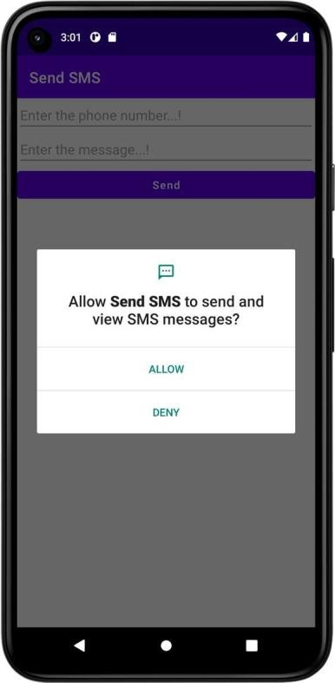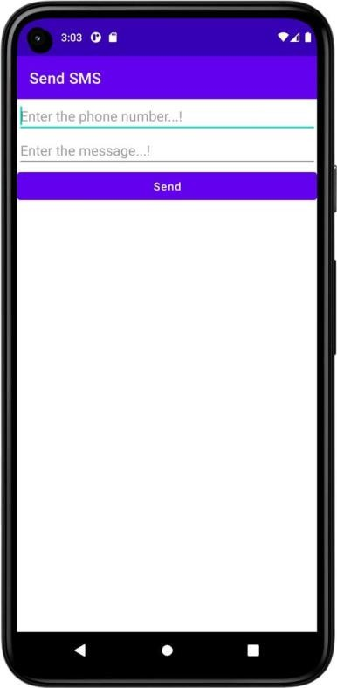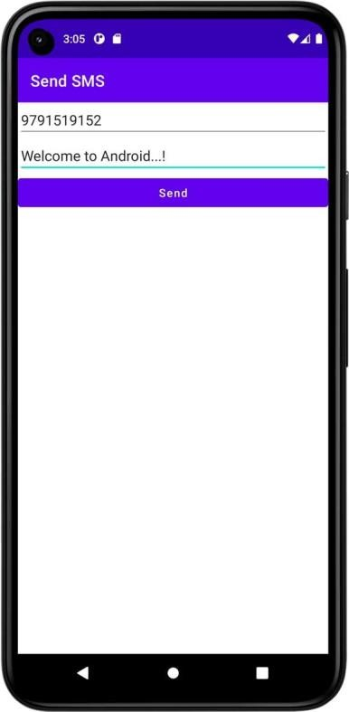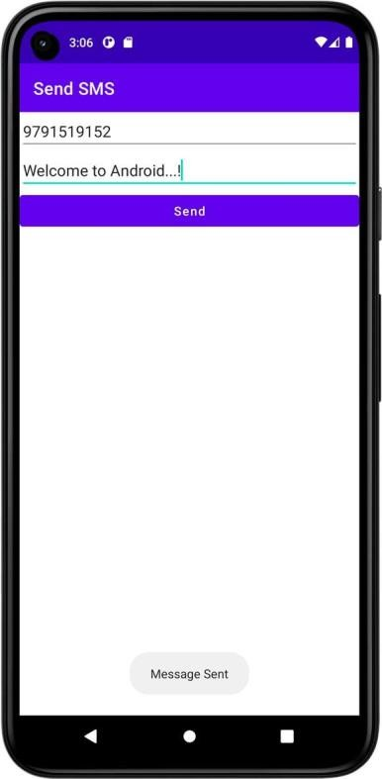

**Result**

**Dept. of Computer Science and Engineering** | **Rajalakshmi Engineering College**

|  |  |  |
| --- | --- | --- |
| **Ex. No. :**  **Register No. :** | **12** | **Date :**  **Name :** |
|  |  | **Send Email** |
| **Aim** |  |  |



Develop an application to send Email.

# Procedure

**Dept. of Computer Science and Engineering** | **Rajalakshmi Engineering College**

**81**

# AndroidManifest.xml

**82**

*<?*xml version="1.0" encoding="utf-8"*?>*

<manifest xmlns:android="<http://schemas.android.com/apk/res/android>" xmlns:tools="<http://schemas.android.com/tools>">

<application

android:allowBackup="true" android:dataExtractionRules="@xml/data_extraction_rules" android:fullBackupContent="@xml/backup_rules" android:icon="@mipmap/ic_launcher" android:label="@string/app_name" android:supportsRtl="true" android:theme="@style/Theme.SendEmail" tools:targetApi="31">

<activity

android:name=".MainActivity" android:exported="true">

<intent-filter>

<action android:name="android.intent.action.MAIN" />

<category android:name="android.intent.category.LAUNCHER" />

</intent-filter>

</**activity**>

</**application**>

</**manifest**>

**Dept. of Computer Science and Engineering** | **Rajalakshmi Engineering College**

# activity_main.xml



*<?*xml version="1.0" encoding="utf-8"*?>*

<LinearLayout xmlns:android="<http://schemas.android.com/apk/res/android>" xmlns:app="<http://schemas.android.com/apk/res-auto>" xmlns:tools="<http://schemas.android.com/tools>" android:layout_width="match_parent" android:layout_height="match_parent"

android:orientation="vertical" tools:context=".MainActivity">

<TextView

android:id="@+id/tvEmail" android:layout_width="match_parent" android:layout_height="wrap_content" android:text="To" />

<EditText

android:id="@+id/etEmail" android:layout_width="match_parent" android:layout_height="wrap_content" android:ems="10" android:inputType="textPersonName" />

<TextView

android:id="@+id/tvSubject" android:layout_width="match_parent" android:layout_height="wrap_content" android:text="Subject" />

<EditText

android:id="@+id/etSubject" android:layout_width="match_parent" android:layout_height="wrap_content" android:ems="10" android:inputType="textPersonName" />

<TextView

android:id="@+id/tvMessage" android:layout_width="match_parent" android:layout_height="wrap_content" android:text="Message" />

<EditText

android:id="@+id/etMessage" android:layout_width="match_parent" android:layout_height="wrap_content" android:ems="10" android:inputType="textPersonName" />

<Button

android:id="@+id/btSend" android:layout_width="match_parent" android:layout_height="wrap_content" android:text="Send" android:textAllCaps="false" />

</LinearLayout>

**Dept. of Computer Science and Engineering** | **Rajalakshmi Engineering College**

**83**

# MainActivity.kt

**package** org.rajalakshmi.sendemail

**import** android.content.Intent

**import** androidx.appcompat.app.AppCompatActivity

**import** android.os.Bundle **import** android.widget.Button **import** android.widget.EditText **import** android.widget.TextView

**class** MainActivity : AppCompatActivity() {

**override fun** onCreate(savedInstanceState: Bundle?) { **super**.onCreate(savedInstanceState) setContentView(R.layout.*activity_main*)

**val** etEmail : EditText = findViewById(R.id.*etEmail*)

**val** etSubject : EditText = findViewById(R.id.*etSubject*) **val** etMessage : EditText = findViewById(R.id.*etMessage*) **val** btSend : Button = findViewById(R.id.*btSend*)

**:"**))

btSend.setOnClickListener **{**

**val** email = etEmail.*text*.toString()

**val** subject = etSubject.*text*.toString() **val** message = etMessage.*text*.toString() **val** intent = Intent(Intent.*ACTION_SEND*)

intent.putExtra(Intent.*EXTRA_EMAIL*, *arrayOf*(email)) intent.putExtra(Intent.*EXTRA_SUBJECT*, subject) intent.putExtra(Intent.*EXTRA_TEXT*, message) intent.*type* = **"message/rfc822"**

startActivity(Intent.createChooser(intent, **"Choose an Email client**

**}**

**84**

}

}

**Dept. of Computer Science and Engineering** | **Rajalakshmi Engineering College**

# Output

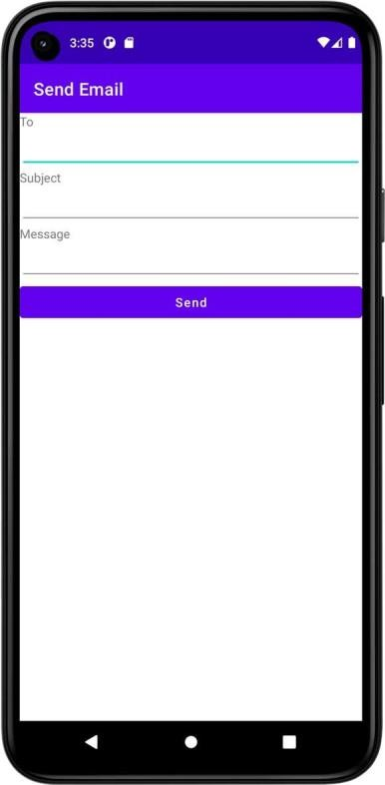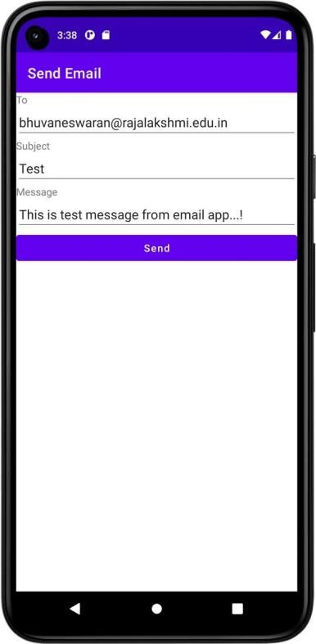

**Result**

**Dept. of Computer Science and Engineering** | **Rajalakshmi Engineering College**

**85**

**Ex. No. : 13 Date :**

**86**

**Register No. : Name :**

**Text to Speech**

**Aim**

Develop an android application to perform Text to Speech.

# Procedure

**Dept. of Computer Science and Engineering** | **Rajalakshmi Engineering College**

# AndroidManifest.xml



*<?*xml version="1.0" encoding="utf-8"*?>*

<manifest xmlns:android="<http://schemas.android.com/apk/res/android>" xmlns:tools="<http://schemas.android.com/tools>">

<application

android:allowBackup="true" android:dataExtractionRules="@xml/data_extraction_rules" android:fullBackupContent="@xml/backup_rules" android:icon="@mipmap/ic_launcher" android:label="@string/app_name" android:supportsRtl="true" android:theme="@style/Theme.TextToSpeech" tools:targetApi="31">

<activity

android:name=".MainActivity" android:exported="true">

<intent-filter>

<action android:name="android.intent.action.MAIN" />

<category android:name="android.intent.category.LAUNCHER" />

</intent-filter>

</**activity**>

</**application**>

</**manifest**>

**Dept. of Computer Science and Engineering** | **Rajalakshmi Engineering College**

**87**

# activity_main.xml

**88**

*<?*xml version="1.0" encoding="utf-8"*?>*

<LinearLayout xmlns:android="<http://schemas.android.com/apk/res/android>" xmlns:app="<http://schemas.android.com/apk/res-auto>" xmlns:tools="<http://schemas.android.com/tools>" android:layout_width="match_parent" android:layout_height="match_parent"

android:orientation="vertical" tools:context=".MainActivity">

<EditText

android:id="@+id/etText" android:layout_width="match_parent" android:layout_height="wrap_content" android:ems="10" android:hint="Enter the text..!" android:inputType="textPersonName" android:textSize="24sp" />

<Button

android:id="@+id/btSpeak" android:layout_width="match_parent" android:layout_height="wrap_content" android:text="Speak" android:textAllCaps="false" android:textSize="24sp" />

</LinearLayout>

**Dept. of Computer Science and Engineering** | **Rajalakshmi Engineering College**

# MainActivity.kt



**package** org.rajalakshmi.texttospeech

**import** androidx.appcompat.app.AppCompatActivity

**import** android.os.Bundle

**import** android.speech.tts.TextToSpeech

**import** android.widget.Button **import** android.widget.EditText **import** android.widget.Toast **import** java.util.*

**class** MainActivity : AppCompatActivity(), TextToSpeech.OnInitListener {

**lateinit var tts** : TextToSpeech

**lateinit var btSpeak** : Button

**override fun** onCreate(savedInstanceState: Bundle?) { **super**.onCreate(savedInstanceState) setContentView(R.layout.*activity_main*)

**val** etText : EditText = findViewById(R.id.*etText*) **btSpeak** = findViewById(R.id.*btSpeak*) **btSpeak**.*isEnabled* = **false**

**tts** = TextToSpeech(**this**, **this**)

**btSpeak**.setOnClickListener **{**

**val** text = etText!!.*text*.toString()

**tts**!!.speak(text, TextToSpeech.*QUEUE_FLUSH*, **null**,**""**)

**}**

}

**override fun** onInit(status: Int) {

**if** (status == TextToSpeech.*SUCCESS*) {

**val** result = **tts**!!.setLanguage(Locale.*US*)

**if** (result == TextToSpeech.*LANG_MISSING_DATA* || result == TextToSpeech.*LANG_NOT_SUPPORTED*) {

Toast.makeText(*applicationContext*, **"The Language not supported...!"**, Toast.*LENGTH_LONG*).show()

}

else {

**btSpeak**!!.*isEnabled* = **true**

}

}

}

}

**Dept. of Computer Science and Engineering** | **Rajalakshmi Engineering College**

**89**

# Output

**90**

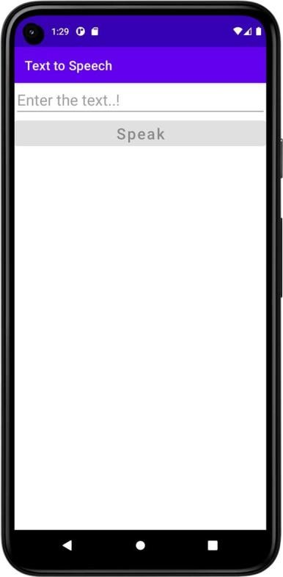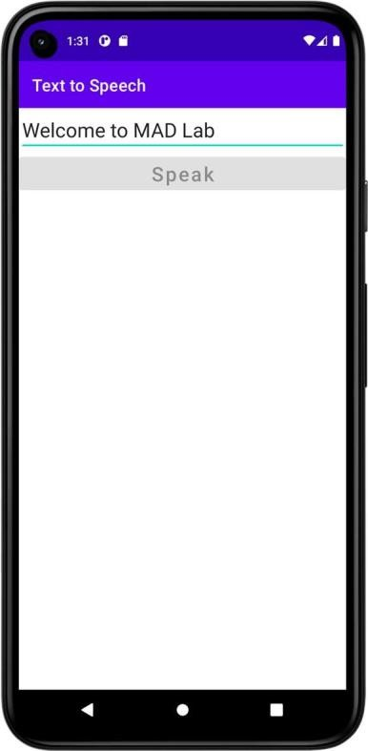

**Result**

**Dept. of Computer Science and Engineering** | **Rajalakshmi Engineering College**

**Ex. No. : 14 Date :**



**Register No. : Name :**

**Speech to Text**

**Aim**

Develop an android application to perform Speech to Text.

# Procedure

**Dept. of Computer Science and Engineering** | **Rajalakshmi Engineering College**

**91**

# AndroidManifest.xml

**92**

*<?*xml version="1.0" encoding="utf-8"*?>*

<manifest xmlns:android="<http://schemas.android.com/apk/res/android>" xmlns:tools="<http://schemas.android.com/tools>">

<application

android:allowBackup="true" android:dataExtractionRules="@xml/data_extraction_rules" android:fullBackupContent="@xml/backup_rules" android:icon="@mipmap/ic_launcher" android:label="@string/app_name" android:supportsRtl="true" android:theme="@style/Theme.SpeechToText" tools:targetApi="31">

<activity

android:name=".MainActivity" android:exported="true">

<intent-filter>

<action android:name="android.intent.action.MAIN" />

<category android:name="android.intent.category.LAUNCHER" />

</intent-filter>

</**activity**>

</**application**>

</**manifest**>

**Dept. of Computer Science and Engineering** | **Rajalakshmi Engineering College**

# activity_main.xml



*<?*xml version="1.0" encoding="utf-8"*?>*

<LinearLayout xmlns:android="<http://schemas.android.com/apk/res/android>" xmlns:app="<http://schemas.android.com/apk/res-auto>" xmlns:tools="<http://schemas.android.com/tools>" android:layout_width="match_parent" android:layout_height="match_parent"

android:orientation="vertical" tools:context=".MainActivity">

<ImageView

android:id="@+id/imgMic" android:layout_width="match_parent" android:layout_height="250dp" app:srcCompat="@android:drawable/ic_btn_speak_now" />

<TextView

android:id="@+id/tvText" android:layout_width="match_parent" android:layout_height="wrap_content" android:text="Output appears here...!" android:textSize="24sp" />

</LinearLayout>

**Dept. of Computer Science and Engineering** | **Rajalakshmi Engineering College**

**93**

# MainActivity.kt

**94**

**package** org.rajalakshmi.speechtotext

**import** android.content.Intent

**import** androidx.appcompat.app.AppCompatActivity

**import** android.os.Bundle

**import** android.speech.RecognizerIntent **import** android.widget.ImageView **import** android.widget.TextView

**import** java.util.*

**class** MainActivity : AppCompatActivity() {

**lateinit var tvText** : TextView

private val REQUEST_CODE_SPEECH_INPUT = 1000

**override fun** onCreate(savedInstanceState: Bundle?) { **super**.onCreate(savedInstanceState) setContentView(R.layout.*activity_main*)

**var** imgMic : ImageView = findViewById(R.id.*imgMic*) **tvText** = findViewById(R.id.*tvText*) imgMic.setOnClickListener **{**

**val** intent = Intent(RecognizerIntent.*ACTION_RECOGNIZE_SPEECH*) intent.putExtra(RecognizerIntent.*EXTRA_LANGUAGE_MODEL*,

RecognizerIntent.*LANGUAGE_MODEL_FREE_FORM*) intent.putExtra(RecognizerIntent.*EXTRA_LANGUAGE*,

Locale.getDefault())

intent.putExtra(RecognizerIntent.*EXTRA_PROMPT*, **"Speak...!"**) startActivityForResult(intent, **REQUEST_CODE_SPEECH_INPUT**)

**}**

}

**override fun** onActivityResult(requestCode: Int, resultCode: Int, data: Intent?) {

**super**.onActivityResult(requestCode, resultCode, data)

**if**(requestCode == **REQUEST_CODE_SPEECH_INPUT** && resultCode == *RESULT_OK*

&& data != **null**) {

**var** res : ArrayList<String> = data.getStringArrayListExtra(RecognizerIntent.*EXTRA_RESULTS*) **as** ArrayList<String>

**tvText**.setText( Objects.requireNonNull(res)[0])

}

}

}

**Dept. of Computer Science and Engineering** | **Rajalakshmi Engineering College**

# Output

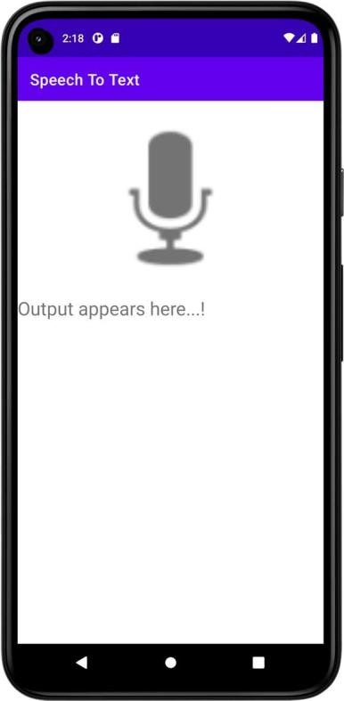

**Result**

**Dept. of Computer Science and Engineering** | **Rajalakshmi Engineering College**

**95**

**Ex. No. : 15 Date :**

**96**

**Register No. : Name :**

**Image Capture**

**Aim**

Develop an android application to capture image using camera and displaying the image using ImageView.

# Procedure

**Dept. of Computer Science and Engineering** | **Rajalakshmi Engineering College**

# AndroidManifest.xml



*<?*xml version="1.0" encoding="utf-8"*?>*

<manifest xmlns:android="<http://schemas.android.com/apk/res/android>" xmlns:tools="<http://schemas.android.com/tools>">

<application

android:allowBackup="true" android:dataExtractionRules="@xml/data_extraction_rules" android:fullBackupContent="@xml/backup_rules" android:icon="@mipmap/ic_launcher" android:label="@string/app_name" android:supportsRtl="true" android:theme="@style/Theme.ImageCapture" tools:targetApi="31">

<activity

android:name=".MainActivity" android:exported="true">

<intent-filter>

<action android:name="android.intent.action.MAIN" />

<category android:name="android.intent.category.LAUNCHER" />

</intent-filter>

</**activity**>

</**application**>

</**manifest**>

**Dept. of Computer Science and Engineering** | **Rajalakshmi Engineering College**

**97**

# activity_main.xml

**98**

*<?*xml version="1.0" encoding="utf-8"*?>*

<LinearLayout xmlns:android="<http://schemas.android.com/apk/res/android>" xmlns:app="<http://schemas.android.com/apk/res-auto>" xmlns:tools="<http://schemas.android.com/tools>" android:layout_width="match_parent" android:layout_height="match_parent"

android:orientation="vertical" tools:context=".MainActivity">

<ImageView

android:id="@+id/imgImage" android:layout_width="match_parent" android:layout_height="500dp" app:srcCompat="@android:drawable/ic_menu_camera" />

<Button

android:id="@+id/btTakePicture" android:layout_width="match_parent" android:layout_height="wrap_content" android:inputType="textCapWords" android:text="Take Picture" />

</LinearLayout>

**Dept. of Computer Science and Engineering** | **Rajalakshmi Engineering College**

# MainActivity.kt



**package** org.rajalakshmi.imagecapture

**import** android.content.Intent

**import** android.graphics.Bitmap

**import** androidx.appcompat.app.AppCompatActivity

**import** android.os.Bundle

**import** android.provider.MediaStore **import** android.widget.Button **import** android.widget.ImageView

**class** MainActivity : AppCompatActivity() {

**lateinit var imgImage** : ImageView

private val REQUEST_CODE_IMAGE_CAPTURE = 1000

**override fun** onCreate(savedInstanceState: Bundle?) { **super**.onCreate(savedInstanceState) setContentView(R.layout.*activity_main*)

**imgImage** = findViewById(R.id.*imgImage*)

**val** btTakePicture : Button = findViewById(R.id.*btTakePicture*)

btTakePicture.setOnClickListener **{**

**val** intent = Intent(MediaStore.*ACTION_IMAGE_CAPTURE*) startActivityForResult(intent, **REQUEST_CODE_IMAGE_CAPTURE**)

**}**

}

**override fun** onActivityResult(requestCode: Int, resultCode: Int, data: Intent?) {

**super**.onActivityResult(requestCode, resultCode, data)

**if**(requestCode == **REQUEST_CODE_IMAGE_CAPTURE** && resultCode == *RESULT_OK*)

{

**val** photo = data!!.*extras*!![**"data"**] **as** Bitmap?

**imgImage**.setImageBitmap(photo)

}

}

}

**Dept. of Computer Science and Engineering** | **Rajalakshmi Engineering College**

**99**

# Output

**100**

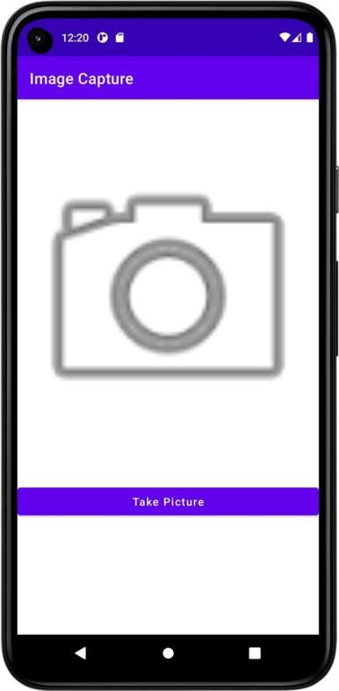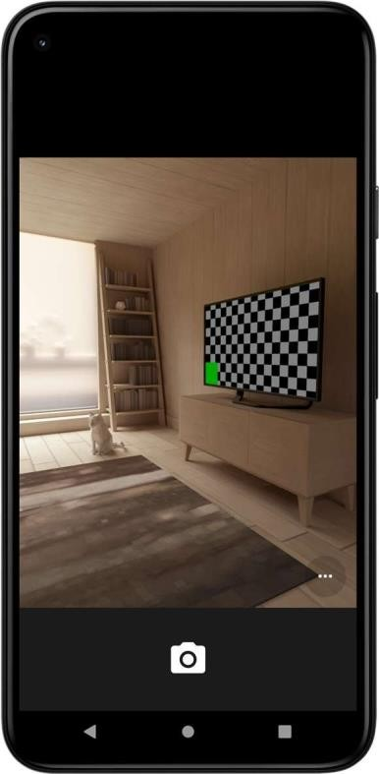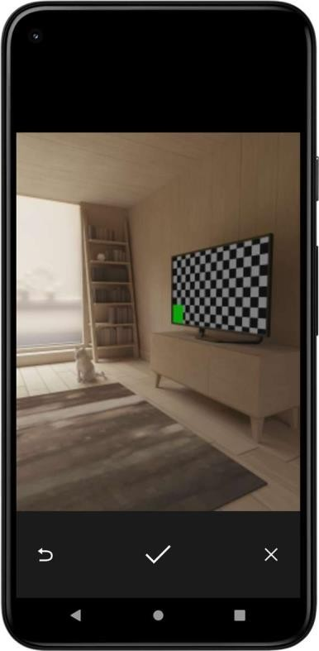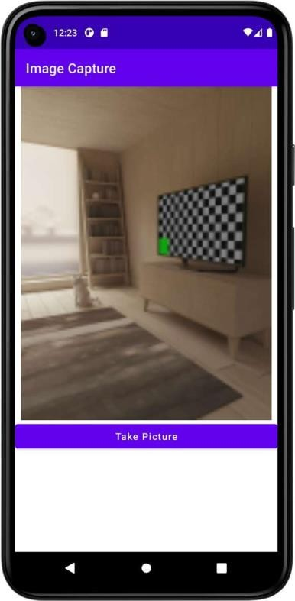

**Result**

**Dept. of Computer Science and Engineering** | **Rajalakshmi Engineering College**